For Property Owners

Home Modification Loan Program

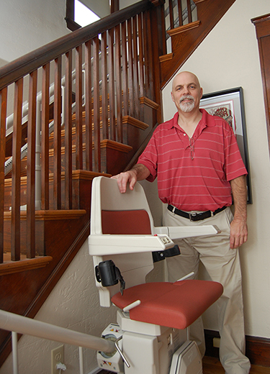The state-funded Home Modification Loan Program provides low- and no-interest loans to make modifications to the homes of elders, adults with disabilities, and families with children with physical, cognitive and/ or emotional disabilities. These modifications allow people to remain in their homes and live independently in their communities. Typical modifications include installation of ramps and lifts, widening of doorways, and alteration of kitchens and bathrooms.

Who is eligible?
Any homeowner who has a disability, has a household member who has a disability, or rents to an individual with a disability may apply for a loan. Income guidelines are based on the total household gross income of the homeowner.
The home requiring modifications must be the primary, principal residence of the individual with a disability. Modifications must be necessary to allow the beneficiary to remain in the home. Scroll down to download the application.

How does it work?
Based on the income guidelines below, $1,000 – $30,000 may be borrowed in either a deferred payment loan (DPL) or an amortized loan. Homeowners eligible for a 0% DPL will not have to repay the loan until the property is sold or the title has been transferred. 0% amortizing loans, 3% DPL and 3% amortizing loans must be paid in 5 to 15 years, depending on the amount of the loan, and require monthly payments. The interest rate for property owners applying for a home modification loan for a rental unit is 3%.

2016 Income Guidelines
Income guidelines are based on HUD published median income for the Boston MESA and are updated annually.
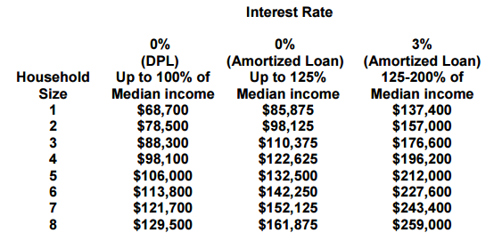

Contractors
Need a contractor for your home modification? View this list of contractors.

Apply
Fill out the Home Modification Loan Program application and submit the signed, completed form to Alan Trebat at Community Teamwork, 155 Merrimack Street, Lowell, MA 01852, or you can also use the online application form.

Contact
For more information about the Home Modification Loan Program, contact Home Modification Loan Program Coordinator Alan Trebat at (978) 654-5741 or atrebat@commteam.org

