REGISTRATION & SPONSORSHIPS FOR BIG BROTHERS BIG SISTERS 15TH ANNUAL GOLF CLASSIC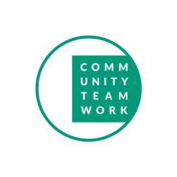
Name | Cost | Description
Tournament Sponsor - Exclusive | $ 5,000.00 | - Banner on golf registration page  - Mention in all event promotion (including social media, radio and print media)  - Mention from podium at tournament  - Acknowledgement on signage at tournament  - Logo on www.commteam.org partner page  - Full page acknowledgement in Event Program  - Acknowledgement on signage at tournament
Lunch or Dinner Sponsor – Exclusive | $ 2,500.00 | - Mention in all event promotion (including social media, radio and print media)  - Mention from podium at tournament  - Logo on www.commteam.org partner page  - Half page acknowledgement in Event Program
At the Turn Sponsor - Exclusive | $ 1,500.00 | - Mention in all event promotion (including social media, radio and print media)  - Mention from podium at tournament  - Logo on www.commteam.org partner page  - Acknowledgement in Event Program
Action Hole Sponsor | $ 500.00 | - Mention on social media as Action Hole Sponsor  - Corporate Logo at one of 3 action holes  - Mention from podium at tournament
Hole Sign Sponsor | $ 250.00 | - Your logo included on a hole sponsorship sign
Cart Sponsor | $ 100.00 | - Logo on one (1) cart
Individual Golfer | $ 250.00 | - Includes Golf for 1, lunch, dinner and awards reception
Foursome | $ 1,000.00 | - Includes Golf for 4, lunch, dinner and awards reception
Dinner Only | $ 50.00 | - Cocktail hour, dinner and awards reception only. Golf not included
Raffle Tickets | $ 20.00 | - Sheet of raffle tickets
General Donation | $ | - Thank you!

