Mayor’s Holiday Fest for Homeless Youth
Rock n’ Roll Fundraiser

Tickets $20 / Person
Sponsor Opportunities
Gold Sponsor $1,000
- Logo displayed on CTI Mayor’s Holiday Fest website and special inclusion in newspaper and radio coverage
- Check presentation photo op: will also appear on www.commteam.org
- Logo displayed at Event and on Event Program
- Mention from podium and on all social media

Silver Sponsor $ 500

- Check presentation photo op: will also appear on www.commteam.org
- Logo displayed at Event and on Event Program
- Mention from podium and on all social media

Bronze Sponsor $ 250

- Logo displayed at Event and on Event Program
- Mention from podium and on all social media

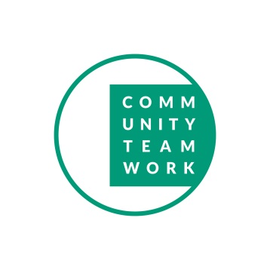
All proceeds from the event will be donated to Community Teamwork Incorporated (CTI)
Mayor’s Fund to End Youth Homelessness
#LowellYouthHousing

