                     Community Teamwork
                          Financial Education Center
                              Division of Energy and Community Resources
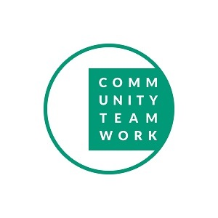One-on-One Financial Coaching
...Helping families achieve financial goals

Community Teamwork’s Financial Coaching program is designed to help you take control of your finances and secure your financial future!

Certified financial coaches will work with you to on ways to:

• Increase your monthly income
• Eliminate and manage debt
• Repair and improve credit
• Understand and take advantage of tax credits
• Create a savings plan

Things to know:

Financial coaching is FREE. 
You’ll be paired with an experienced CTI Certified Financial Coach 
Flexible appointments make it possible for you to keep your work  schedule.  Appointments are available throughout the day, in the early morning and on Wednesday nights.
 
Please call to schedule your appointment and safeguard your financial future! 
978-654-5673
 
 
Community Teamwork- Financial Education Center
165 Merrimack Street
Lowell, MA 01852
978-654-5673
 
