Public Policy Priorities
Our public policy priorities support our mission to collectively advocate along with the State’s 23 Community Action Agencies for an end to poverty. Every day we work together to help MA residents living with low incomes to stabilize their lives and achieve economic prosperity.
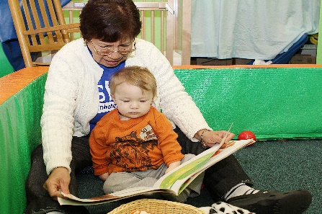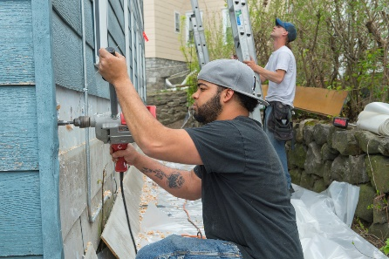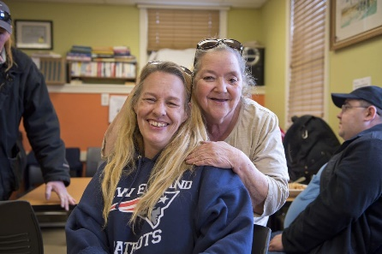
Our FY19 Top Budget Priorities

Strengthening Families through Affordable and Accessible Early Education and Care
- Increase Early Education Teacher Salary Line Item (3000-1042) - $20.4M
- Increase Head Start Line Item (3000-5000) - $12M
- Increase Child Care Resource Referral Access Management in Early Education Program (3000-2000) – $8.675M
Bridging the Wage Gap
- Expand State Earned Income Tax Credit (EITC) to 30% of Federal - $260M
- Increase Resources for Volunteer Income Tax Assistance (VITA) Program Sites (1201-0100) - $800,000
Creating a Foundation for Economic Opportunity
- Add Supplemental FY18 Allocation for Fuel Assistance (7004-xxxx) - $25M
- Support Services for Unaccompanied Youth Housing and Wraparound Services (4000-0007) - $4M
Our Statewide Impact
- +600,000 served annually
- +30,000 obtained child care including before/after school care
- +8,500 served by Head Start
- +17,000 accessed free tax prep bringing back +$32M in tax credits
- 3,114 obtained employment
- +160,000 received fuel assistance
- 3,664 households weatherized
- 614,253 volunteer hours donated from those we serve

