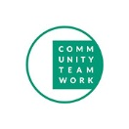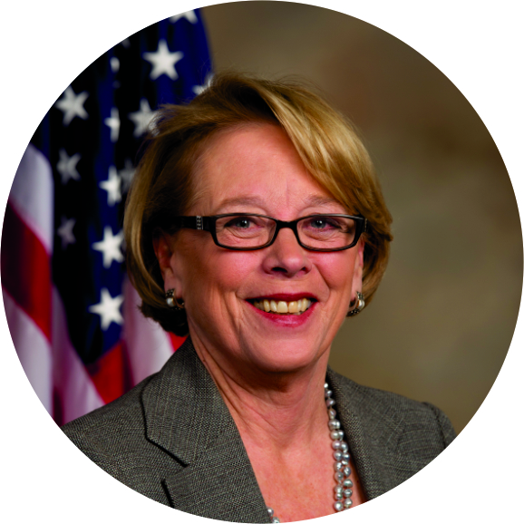
ANNUAL SPRING GALA HONORING U.S. REPRESENTATIVE NIKI TSONGAS

Tickets and Sponsorship Packages

JOHNNY CARSON SPONSOR* $20,000.00
• Two (2) tables of 10 with preferred seating
• Logo displayed at Event and on event program, on website and social media
• Check presentation photo op (will also appear on www.commteam.org until the 2019 Event)
• Mention from podium and in all media releases (including Newsletter, TV 6 Radio)
• Acknowledgment as sponsor for two (2) additional Community Teamwork events or programs
• First right of refusal as Premier Sponsor for 2019 Fundraising Event

JIMMY FALLON SPONSOR* $10,000.00
• Two (2) tables of ten (10)
• Logo displayed at Event and on event program, on website and social media
• Check presentation photo op
• Mention from podium and on all social media
• Acknowledgment as sponsor of one (1) additional Community Teamwork event or program.

JAY LENO SPONSOR* $5,000.00
• One (1) table of ten (10)
• Logo displayed on website
• Name in event program
• Mention from podium and on social media

JACK PAAR SPONSOR* $2,500.00
• One (1) table of ten (10)
• Name in event program
• Mention from podium and on social media

JOAN RIVERS SPONSOR* $1,000.00
• One (1) table of ten (10)
• Name in event program

ED MCMAHON TICKET PRICE $100.00 EACH OR $175/PAIR
*Qualifies for Community Investment Tax Credit (CITC) Refund

