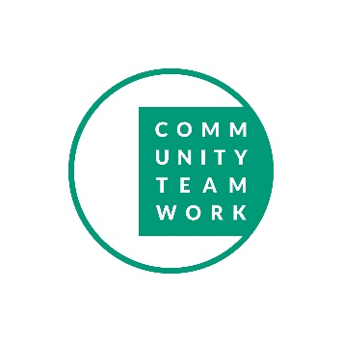 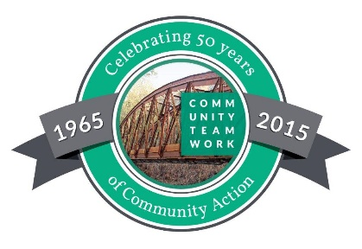

PLEASE REGISTER ONLINE AT [www.commteam.org](http://www.commteam.org) or

EMAIL CATHY DYL at [cdyl@commteam.org](mailto:cdyl@commteam.org) for addresses and questions

All Pre – Purchase First Time Home Buyer seminars are $60 per Household

HOME BUYER SEMINARS - 2019

|  |  |  |
| --- | --- | --- |
| Dates | Location | Time |
| Jan 12 & 19 | Salem | 8:45 a.m. - 1:30 p.m. |
| Jan 26 & Feb 2 | Beverly | 8:45 a.m. -1:30 p.m. |
| Feb 9 & 16 | Woburn | 8:45 a.m. - 1:30 p.m. |
| Feb 23 & Mar 2 | Salem | 8:45 a.m. – 1:30 p.m. |
| Mar 9 & 16 | Woburn | 8:45 a.m. – 1:30 p.m. |
| Mar 19, 21, 26, 28 | Chelmsford | 6:15 p.m. – 8:30 p.m. |
| April 6 & 13 | Beverly | 8:45 a.m. – 1:30 p.m. |
| April 9, 11, 16, 18 | Wakefield | 6:15 a.m. – 8:30 p.m. |
| May 4 & 11 | Billerica | 8:45 a.m. – 1:30 p.m. |
| May 11 & 18 | Melrose | 8:45 a.m. – 1:30 p.m. |
| June 1 & 8 | Beverly | 8:45 a.m. - 1:30 p.m. |
| June 15 & 22 | Woburn | 8:45 a.m. – 1:30 p.m. |
| July 20 & 27 | Woburn | 8:45 a.m. – 1:30 p.m. |
| Sept 14 & 21 | Woburn | 8:45 a.m. – 1:30 p.m |
| Sept 21 & 28 | Beverly | 8:45 a.m. – 1:30 p.m. |
| Oct 22, 23, 29, 30 | Billerica | 6:15 p.m. – 8:30 p.m. |
| Oct 19 & 26 | Wakefield | 8:45 a.m. - 1:30 p.m. |
| Nov 9 & 16 | Beverly | 8:45 a.m. – 1:30 p.m. |
| December 7 & 14 | Salem | 8:45 a.m. – 1:30 p.m. |

j0406378 

11/11/18