Mill City Mentors Program

WHY MENTOR?

Mentoring, at its core, guarantees young people that there is someone who cares about them, assures them they are not alone in dealing with day-to-day challenges, and makes them feel like they matter. Research confirms that quality mentoring relationships have powerful positive effects on young people in a variety of personal, academic, and professional situations. Ultimately, mentoring connects a young person to personal growth and development, and social and economic opportunity. Yet one in three young people will grow up without this critical asset.

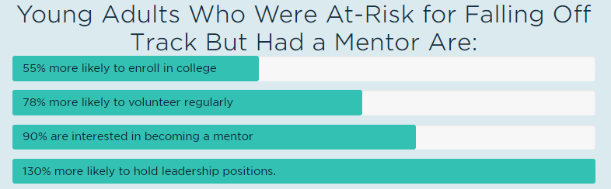

Mill City Mentors is a mentoring program of Community Teamwork that strives to provide positive, caring mentors to youth facing adversity and in need of additional support to increase confidence, self-esteem, and be empowered to create their best life. Our program focuses on youth ages 7 through 22.

Our vision is to provide support to youth, their families, and mentors to collectively establish a positive and successful future for the youth of our community. By utilizing effective mentoring models that will best suit each individual youth, we will empower our youth to strive for the lives they want and have the structure and support to attain it.

Mill City Mentors is on the forefront of understanding the needs of our at-risk population in the Greater Lowell area. Our agency is at the heart of all community action services in the Greater Lowell area. Due to that, we are in the best position to create and support mentoring opportunities that individually benefit the youth in our community through 1:1 mentoring as well as site based and group mentoring opportunities to strengthen our youth.

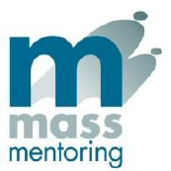
For More Information Please Visit www.commteam.org/millcitymentors or Call (978) 459-0551
