OVERVIEW
Amesbury is a suburban community of 16,283 residents located just south of the New Hampshire border and west of Salisbury in Essex County. The town is located along the Merrimack and Powow Rivers and has a rich manufacturing history. The majority of housing in town are single-family homes, however there are also many multi-family homes available.

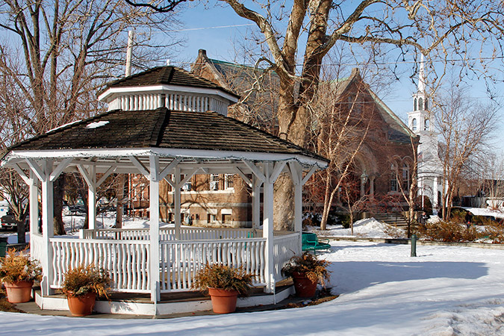Amesbury Town Common (Photo Source: Yankee Magazine)

Community safety
In 2015, the Town of Amesbury’s violent crime rate was 36% higher than the national average and 33% higher than the Massachusetts average. The property crime rate was 66% lower than the national average and 50% lower than the Massachusetts average.

Data Source: www.cityrating.com/crime-statistics

Transportation
Most residents of Amesbury rely on a car for transportation; I-495 runs through town and I-95 is easily accessible. MVRTA 51 and 54 buses provide public transportation to town. The nearest Commuter Rail Station is located in Newburyport, or Haverhill depending on what part of town you live in.

Schools

Amesbury Elementary School (PK – 4)
Great Schools Rating: 5/10

Cashman Elementary School (PK – 4)
Great Schools Rating: 4/10

Amesbury Middle School (5 – 8)
Great Schools Rating: 5/10

Amesbury High School (9 – 12)
Great Schools Rating: 7/10

Whittier Regional Vocational High School (9 – 12)
Great Schools Rating: 6/10

High School Graduation Rate
Amesbury High School | 90.8%
Massachusetts | 87.9%

Data Sources: GreatSchools.org; MA Dept. of Elementary & Secondary Education District Profiles

DEMOGRAPHICS
Poverty Rate: 4.9%

Race/Ethnicity | %
White | 97.8%
Asian | 1.7%
American Indian and Alaska Native | 0.4%
Hispanic or Latino | 2.7%
Black/African American | 2.6%
Native Hawaiian and Other Pacific Islander | 0.0%
Other | 0.3%

Age Group | %
Under 5 | 4.9%
Age 5-17 | 16.3%
Age 18-64 | 63.6%
Age 65 and older | 15.2%

Data Source: American FactFinder, U.S. Census Bureau

Local Amenities

There is limited shopping available in Amesbury, however the town does have two supermarkets. Any shopping trips that cannot be completed in town can be done at a shopping plaza in one of the surrounding towns.

Amesbury is conveniently located along the Merrimack River and a short drive to beach providing many outdoor recreation activities. Additionally, the town also offers many youth recreation opportunities including a before and after school program.

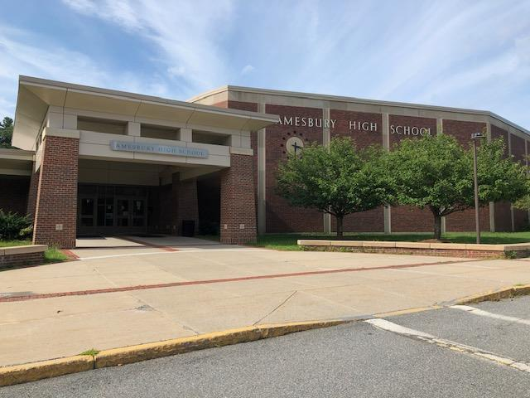
Amesbury High School (Photo Source: Amesbury Public Schools)

MAP

