OVERVIEW
Andover is a suburban community of 35,375 residents located to the south and west of Lawrence in Essex County. Similar to other towns in the Merrimack Valley, Andover has a rich history in manufacturing and retains much of that original character. Many residents live in single-family homes, however the town also has many multi-family homes, and apartment complexes.

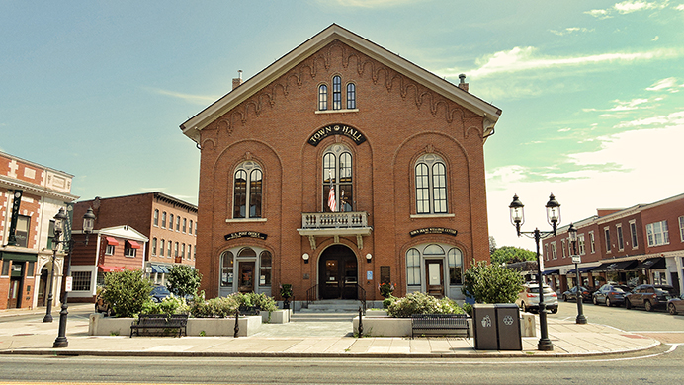Andover Town Hall (Photo Source gambleassoc.com)

Community safety
In 2016, the Town of Andover’s violent crime rate was 84% lower than the national average and 83% lower than the Massachusetts average. The property crime rate was 75% lower than the national average and 61% lower than the Massachusetts average.

Data Source: www.cityrating.com/crime-statistics

Transportation
The majority of Andover residents rely on a car for transportation with both I-495, and I-93 running through town. Additionally, there is public transportation in Andover; the MVRTA 32, 37, and 75 buses, two bus routes to Boston and the Andover Shuttle serve them. There are 2 Commuter Rail Stations in Andover.

Schools

Bancroft Elementary School (K – 5)
Great Schools Rating: 5/10

South Elementary School (K – 5)
Great Schools Rating: 6/10

West Elementary School (PK – 5)
Great Schools Rating: 5/10

High Plain Elementary School (K – 5)
Great Schools Rating: 8/10

Sanborn Elementary School (K – 5)
Great Schools Rating: 6/10

Doherty Middle School (6 – 8)
Great Schools Rating: 6/10

West Middle School (6 – 8)
Great Schools Rating: 5/10

Wood Hill Middle School (6 – 8)
Great Schools Rating: 7/10

Andover High School (9 – 12)
Great Schools Rating: 7/10

Greater Lawrence Technical High School (9 – 12)
Great Schools Rating: 4/10

High School Graduation Rate
Andover High School | 98.3%
Massachusetts | 87.9%

Data Sources: GreatSchools.org; MA Dept. of Elementary & Secondary Education District Profiles

DEMOGRAPHICS
Poverty Rate: 4.4%

Race/Ethnicity | %
White | 83.7%
Asian | 13.5%
American Indian and Alaska Native | 0.6%
Hispanic or Latino | 3.7%
Black/African American | 2.8%
Native Hawaiian and Other Pacific Islander | 0.0%
Other | 1.4%

Age Group | %
Under 5 | 5.4%
Age 5-17 | 20.1%
Age 18-64 | 60.2%
Age 65 and older | 14.3%

Data Source: American FactFinder, U.S. Census Bureau

Local Amenities

Within Andover, there are many shopping plazas and restaurants along with three supermarkets. While many shopping trips can be completed in town, there are also many stores, and shopping malls a short drive away into the surrounding cities and towns.

Andover provides access to green space for many outdoor activities including the Harold Parker State Forest, which offers open space for fishing, camping, hiking, and bike riding, and has easy access to the Shawsheen River.

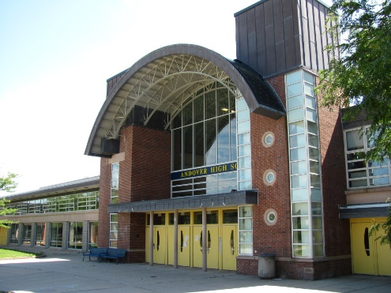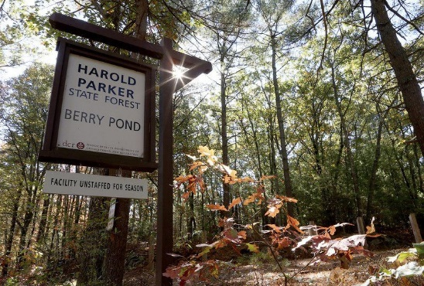
Andover High School/Harold Parker State Forest (Photo Source: Valley Patriot/Eagle Tribune)

MAP

