OVERVIEW
Beverly is an urban community of 39,502 residents located east of Danvers, and north of Salem along the Atlantic coast in Essex County. Despite being a city, it retains a smaller town feel. Housing in town is mixed among single-family homes, multi-family homes, apartment complexes, and townhomes.

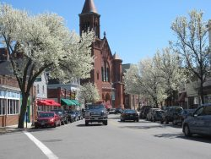Downtown Beverly (Photo Source: Beverly Main Streets)

Community safety
In 2016, the City of Beverly’s violent crime rate was 60% lower than the national average and 58% lower than the Massachusetts average. The property crime rate was 67% lower than the national average and 49% lower than the Massachusetts average.

Data Source: www.cityrating.com/crime-statistics

Transportation
Many residents of Beverly use a car for transportation; Route 128 is easily accessible from the city. Public transportation is available throughout town, it is served by the MBTA 451 Bus, and by the Beverly Shuttle from the Cape Ann Transit Authority. Three Commuter Rail Stations also serve the town.

Schools

Ayers Ryal Side Elementary School (K – 5)
Great Schools Rating: 5/10

Centerville Elementary School (K – 5)
Great Schools Rating: 5/10

Cove Elementary School (K – 5)
Great Schools Rating: 6/10

Hannah Elementary School (K – 5)
Great Schools Rating: 6/10

North Beverly Elementary School (K – 5)
Great Schools Rating: 5/10

Beverly Middle School (6 – 8)
Great Schools Rating: 5/10

Beverly High School (9 – 12)
Great Schools Rating: 4/10

Essex Technical High School (9 – 12)
Great Schools Rating: 7/10

High School Graduation Rate
Beverly High School | 92.4%
Massachusetts | 87.9%

Data Sources: GreatSchools.org; MA Dept. of Elementary & Secondary Education District Profiles

DEMOGRAPHICS
Poverty Rate: 8.3%

Race/Ethnicity | %
White | 96.5%
Asian | 2.1%
American Indian and Alaska Native | 0.4%
Hispanic or Latino | 4.2%
Black/African American | 1.7%
Native Hawaiian and Other Pacific Islander | 0.1%
Other | 0.9%

Age Group | %
Under 5 | 4.0%
Age 5-17 | 13.3%
Age 18-64 | 66.0%
Age 65 and older | 16.7%

Data Source: American FactFinder, U.S. Census Bureau

Local Amenities

Within Beverly, there are many shopping plazas and restaurants, including four supermarkets. Any shopping that cannot be completed in the City can be done at the North Shore Mall in Peabody, MA, which is only a short drive away.

The Beverly Parks and Recreation Department provides a variety of youth programs designed to keep families engaged in the community. The city also has outdoor recreation opportunities and public beaches.

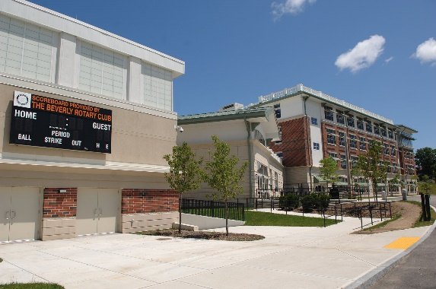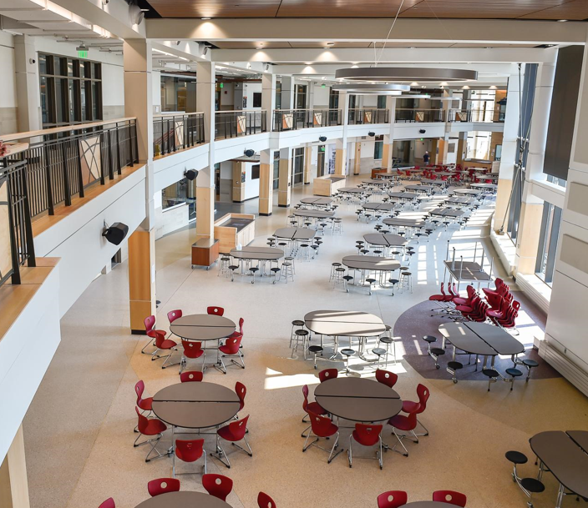
Beverly High School (Photo Source: CTA Construction/Beverly Wicked Local)

MAP

