OVERVIEW
Billerica is a suburban community of 42,791 residents located south of Lowell in Middlesex County. The town is located along the Concord River, and near the Merrimack River. Most families in town live in single-family homes, however there are also multi-family homes and apartments available.

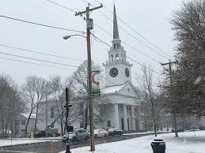Billerica First Parish Church (Photo Source Lowell Sun)

Community safety
In 2016, the Town of Billerica’s violent crime rate was 75% lower than the national average and 73% lower than the Massachusetts average. The property crime rate was 81% lower than the national average and 70% lower than the Massachusetts average.

Data Source: www.cityrating.com/crime-statistics

Transportation
Most residents of Billerica rely on a car for transportation; Route 3 runs through town and I-495 is a short drive away. The LRTA 3, 13, and 14 buses provide the town’s public transportation. Billerica has its own Commuter Rail Station; however, some parts of town are closer to the Wilmington Commuter Rail Station.

Schools

Parker Elementary School (K – 5)
Great Schools Rating: 4/10

Kennedy Elementary School (K – 5)
Great Schools Rating: 7/10

Hajjar Elementary School (K – 5)
Great Schools Rating: 4/10

Dutile Elementary School (K – 5)
Great Schools Rating: 5/10

Ditson Elementary School (K – 5)
Great Schools Rating: 5/10

Marshall Middle School (6 – 8)
Great Schools Rating: 6/10

Locke Middle School (6 – 8)
Great Schools Rating: 5/10

Billerica Memorial High School (9 – 12)
Great Schools Rating: 5/10

Shawsheen Valley Technical High School (9 – 12)
Great Schools Rating: 7/10

High School Graduation Rate
Billerica Memorial High School | 91.0%
Massachusetts | 87.9%

Data Sources: GreatSchools.org; MA Dept. of Elementary & Secondary Education District Profiles

DEMOGRAPHICS
Poverty Rate: 4.3%

Race/Ethnicity | %
White | 87.9%
Asian | 7.0%
American Indian and Alaska Native | 0.5%
Hispanic or Latino | 4.3%
Black/African American | 4.0%
Native Hawaiian and Other Pacific Islander | 0.1%
Other | 2.5%

Age Group | %
Under 5 | 5.3%
Age 5-17 | 14.3%
Age 18-64 | 65.6%
Age 65 and older | 14.8%

Data Source: American FactFinder, U.S. Census Bureau

Local Amenities

There are many shopping plazas within Billerica, including three supermarkets. Additionally, Billerica is only a short drive away from both the Pheasant Lane Mall in Nashua, NH, and the Burlington Mall in Burlington, MA.

Billerica offers many events and programs in town for kids and families including outdoor movie nights in the summer and a variety of other programs including sports and drama. The town also has many parks and conservation areas with hiking trails available to the public.

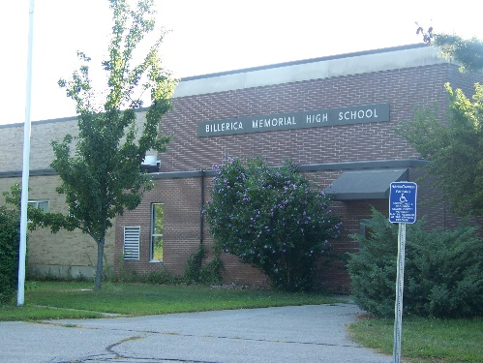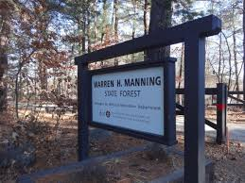
Billerica Memorial High School/Manning State Forest (Photo Source: Billerica Minuteman)

MAP

