OVERVIEW
Boxford is a rural community of 8,228 residents located south of Haverhill in Essex County. The town was originally founded as a farming town and retains much of that rural character. The majority of homes in town are single-family homes and there is a limited availability of multi-family apartments.

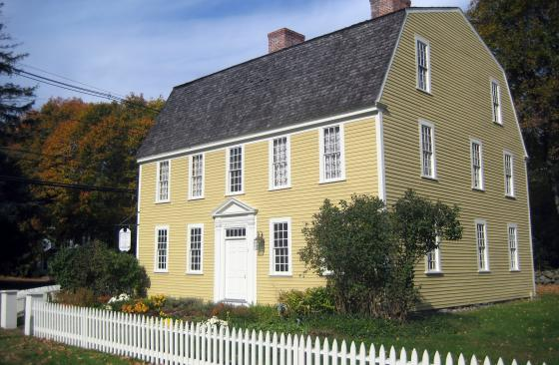Holyoke French House (Photo Source essexheritage.org)

Community safety
In 2016, the Town of Boxford’s violent crime rate was 100% lower than the national average and 100% lower than the Massachusetts average. The property crime rate was 93% lower than the national average and 88% lower than the Massachusetts average.

Data Source: www.cityrating.com/crime-statistics

Transportation
Most residents of Boxford rely on a car; I-95 runs through town and I-495 is easily accessible. Public Transportation is not available in town. The nearest Commuter Rail Station is in either Andover, Haverhill, or Hamilton/Wenham.

Schools

Harry Lee Cole Elementary School (PK – 2)
Great Schools Rating: No Rating

Spofford Pond Elementary School (3 – 6)
Great Schools Rating: 7/10

Masconomet Regional Middle School (7 – 8)
Great Schools Rating: 7/10

Masconomet Regional High School (9 – 12)
Great Schools Rating: 9/10

Essex Technical High School (9 – 12)
Great Schools Rating: 7/10

High School Graduation Rate
Masconomet Regional High School | 99.3%
Massachusetts | 87.9%

Data Sources: GreatSchools.org; MA Dept. of Elementary & Secondary Education District Profiles

DEMOGRAPHICS
Poverty Rate: 2.8%

Race/Ethnicity | %
White | 95.0%
Asian | 5.8%
American Indian and Alaska Native | 2.0%
Hispanic or Latino | 1.8%
Black/African American | 1.1%
Native Hawaiian and Other Pacific Islander | 0.0%
Other | 0.0%

Age Group | %
Under 5 | 4.3%
Age 5-17 | 19.6%
Age 18-64 | 59.2%
Age 65 and older | 16.9%

Data Source: American FactFinder, U.S. Census Bureau

Local Amenities

While there are not many stores or services located directly in Boxford, the surrounding towns have several shopping plazas where most shopping trips can be completed.

The town is heavily forested and offers many hiking trails and access to its many lakes, rivers, and streams. Additionally, the Town of Boxford hosts an annual Apple Festival.

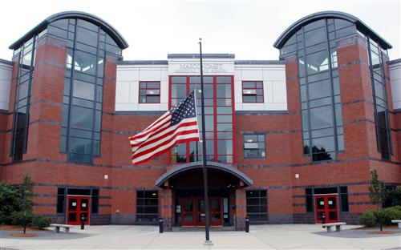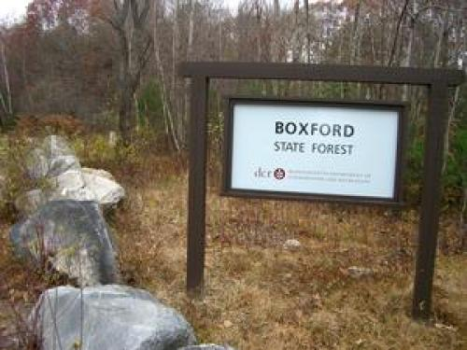
Masconomet Regional High School/Boxford State Forest (Photo Source: Masconomet Regional School District/Essex Heritage)

MAP

