OVERVIEW
Danvers is a suburban community of 27,527 residents located west of Beverly and north of Peabody in Essex County. The town is primarily residential and has many parks in addition to its own marina. The housing in town is mixed between single-family homes, multi-family homes, and apartment complexes.

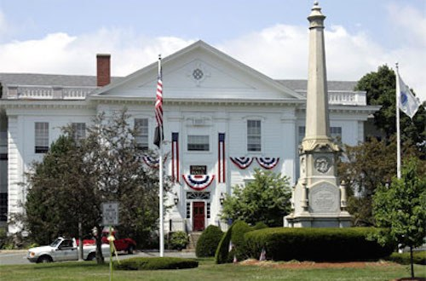Danvers Town Common (Photo Source: LAER Realty)

Community safety
In 2016, the City of Danvers’s violent crime rate was 65% lower than the national average and 63% lower than the Massachusetts average. The property crime rate was 11% lower than the national average and 39% higher than the Massachusetts average.

Data Source: www.cityrating.com/crime-statistics

Transportation
Many residents of Danvers rely on a car for transportation; I-95 run through town. The MBTA 435 and 465 buses provide public transportation to town. The nearest Commuter Rail Stations are each located in Beverly.

Schools

Thorpe Elementary School (K – 5)
Great Schools Rating: 3/10

Smith Elementary School (K – 5)
Great Schools Rating: 6/10

Riverside Elementary School (PK – 5)
Great Schools Rating: 5/10

Highlands Elementary School (K – 5)
Great Schools Rating: 3/10

Great Oak Elementary School (K – 5)
Great Schools Rating: 6/10

Holten-Richmond Middle School (6 – 8)
Great Schools Rating: 4/10

Danvers High School (9 – 12)
Great Schools Rating: 6/10

Essex Technical High School (9 – 12)
Great Schools Rating: 7/10

High School Graduation Rate
Danvers High School | 95.4%
Massachusetts | 87.9%

Data Sources: GreatSchools.org; MA Dept. of Elementary & Secondary Education District Profiles

DEMOGRAPHICS
Poverty Rate: 6.3%

Race/Ethnicity | %
White | 95.4%
Asian | 2.7%
American Indian and Alaska Native | 0.5%
Hispanic or Latino | 4.3%
Black/African American | 2.1%
Native Hawaiian and Other Pacific Islander | 0.0%
Other | 1.3%

Age Group | %
Under 5 | 4.3%
Age 5-17 | 16.0%
Age 18-64 | 58.4%
Age 65 and older | 21.3%

Data Source: American FactFinder, U.S. Census Bureau

Local Amenities

Within Danvers, there are many shopping plazas and restaurants, including three supermarkets. Any shopping that cannot be completed in town can be done at the North Shore Mall in Peabody, MA, which is only a short drive away.

The Town of Danvers has conserved its open space, provides many outdoor recreation opportunities, and has its own marina. The town also provides many recreational programs and activities to residents of all ages, including children.

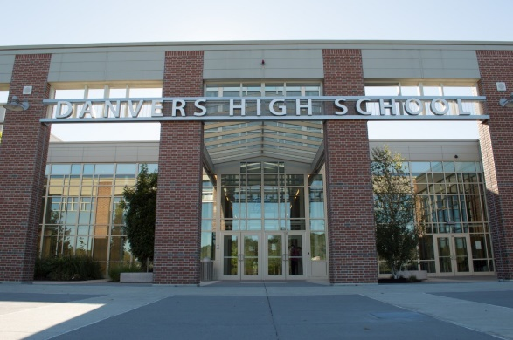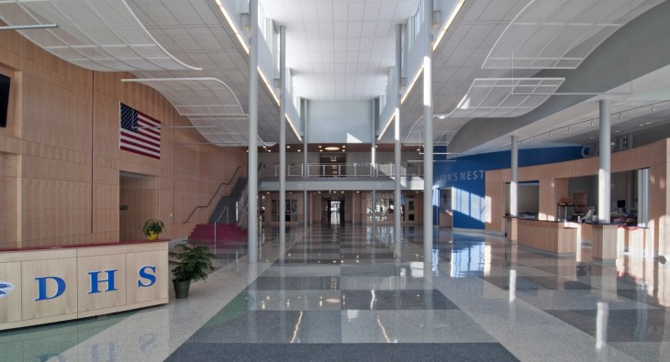
Danvers High School (Photo Source: Danvers Public Schools/DiNIsco Design)

MAP

