OVERVIEW
Dracut is a town of 31,113 residents located North of Lowell, and just south of the New Hampshire border. The town was originally an agricultural town, and now is a primarily residential community that retains much of its original character. Most of the housing in Dracut consists of single-family homes, but there is also a mix of apartment complexes and multi-family homes.

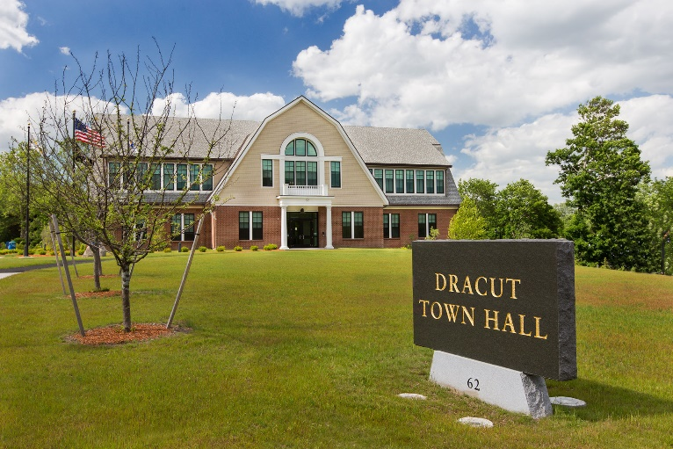Dunstable Town Hall (Photo Source ctaconstruction.com)

Community safety
In 2016, the Town of Dracut’s violent crime rate was 70% lower than the national average and 68% lower than the Massachusetts average. The property crime rate was 48% lower than the national average and 18% lower than the Massachusetts average.

Data Source: www.cityrating.com/crime-statistics

Transportation
Most residents of Dracut rely on a car for transportation. The closest highways are Route 3, I-93 and I-495. Public Transportation in town is limited, however the LRTA 10, and 1 buses serve them. The closest Commuter Rail station is in Lowell.

Schools

Brookside Elementary School (K – 5)
Great Schools Rating: 5/10

George H. Englesby Elementary School (K – 5)
Great Schools Rating: 4/10

Joseph A. Campbell Elementary School (K – 5)
Great Schools Rating: 6/10

Greenmont Avenue Elementary School (K – 5)
Great Schools Rating: 7/10

Justus C. Richardson Middle School (6 – 8)
Great Schools Rating: 6/10

Dracut Senior High School (9 – 12)
Great Schools Rating: 6/10

Greater Lowell Technical High School (Grades 9 – 12)
Great Schools Rating: 4/10

High School Graduation Rate
Dracut Senior High School | 93%
Massachusetts | 87.9%

Data Sources: GreatSchools.org; MA Dept. of Elementary & Secondary Education District Profiles

DEMOGRAPHICS
Poverty Rate: 7.2%

Race/Ethnicity | %
White | 89.4%
Asian | 4.7%
American Indian and Alaska Native | 0.2%
Hispanic or Latino | 5.0%
Black/African American | 6.5%
Native Hawaiian and Other Pacific Islander | 0.4%
Other | 1.8%

Age Group | %
Under 5 | 6.1%
Age 5-17 | 15.8%
Age 18-64 | 63.5%
Age 65 and older | 14.6%

Data Source: American FactFinder, U.S. Census Bureau

Local Amenities

While there are not many shopping plazas within Dracut, they do have one supermarket, with many more nearby in Lowell. Most shopping trips can be completed by taking the short drive to the Pheasant Lane Mall in Nashua, NH, or the Rockingham Mall in Salem, NH.

Within Dracut is the Tyngsborough, Lowell, Dracut State Forest that offers many walking trails, which are open to the public year round. Additionally, the town offers many recreational and sport programs available to residents.

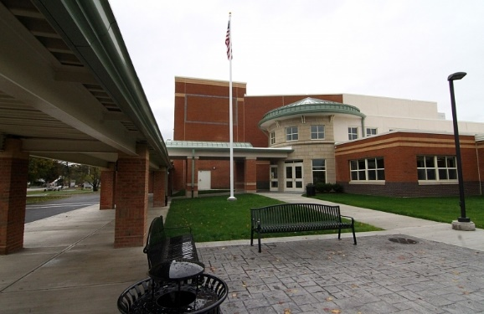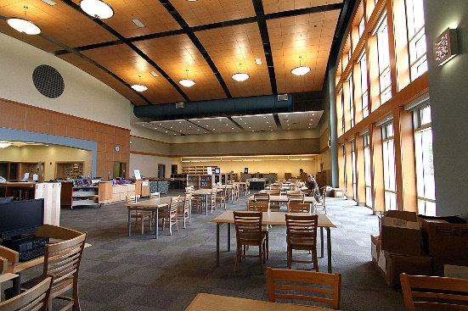
Dracut Senior High School (Photo Source: CTA Construction)

MAP

