OVERVIEW
Essex is a community of 3,687 located north of Manchester and south of Ipswich along the Atlantic coast in Essex County. Located along the coast, the town has a history in shipbuilding and retains a rural character. The majority of housing in town are single-family homes, however multi-family homes are also available.

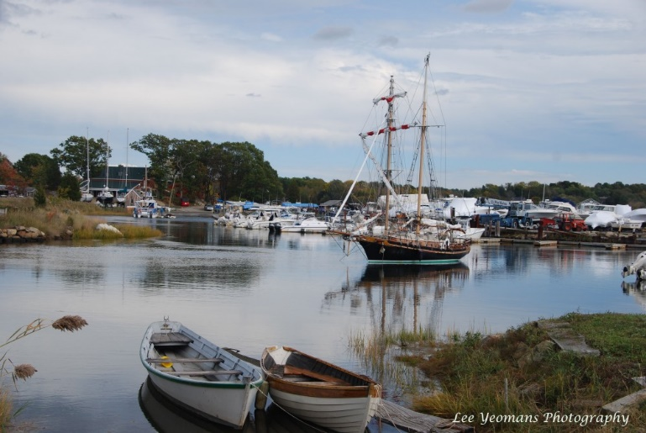Essex Harbor (Photo Source: Yankee Magazine)

Community safety
In 2014, the Town of Essex’s violent crime rate was 100% lower than the national average and 100% lower than the Massachusetts average. The property crime rate was 63% lower than the national average and 48% lower than the Massachusetts average.

Data Source: www.cityrating.com/crime-statistics

Transportation
Most residents of Essex rely on a car for transportation; I-95 is easily accessible from town. Public transportation in town is limited; Cape Ann Transit Authority’s Purple Line Bus provides bus service to town. The nearest Commuter Rail Station is located in Hamilton, Gloucester, or Ipswich depending on what part of town you live in.

Schools

Essex Elementary School (K – 5)
Great Schools Rating: 7/10

Manchester-Essex Regional Middle School (6 – 8)
Great Schools Rating: 7/10

Manchester-Essex Regional High School (9 – 12)
Great Schools Rating: 9/10

Essex Technical High School (9 – 12)
Great Schools Rating: 7/10

High School Graduation Rate
Manchester-Essex Regional High School | 97.8%
Massachusetts | 87.9%

Data Sources: GreatSchools.org; MA Dept. of Elementary & Secondary Education District Profiles

DEMOGRAPHICS
Poverty Rate: 6.2%

Race/Ethnicity | %
White | 99.8%
Asian | 0.0%
American Indian and Alaska Native | 0.3%
Hispanic or Latino | 0.5%
Black/African American | 0.0%
Native Hawaiian and Other Pacific Islander | 0.0%
Other | 0.5%

Age Group | %
Under 5 | 6.9%
Age 5-17 | 16.9%
Age 18-64 | 58.1%
Age 65 and older | 18.1%

Data Source: American FactFinder, U.S. Census Bureau

Local Amenities

The town of Essex has a few shopping centers and restaurants in town; including one supermarket. Any shopping trips that cannot be completed in town can be done in one of the surrounding towns.

Located along the Atlantic Ocean, and Essex River, Essex provides many outdoor recreational opportunities. The town also offers many youth sports activities, and an active downtown area.

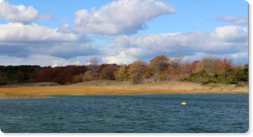
Essex Coastline (Photo Source: essexma.org)

MAP

