OVERVIEW
Georgetown is a rural community of 8,569 residents located southeast of Haverhill and Groveland in Essex County. The town has a history rooted in farming and manufacturing and retains a rural feel. Most of the families in Georgetown live in single-family homes; however there are also have multi-family homes available.

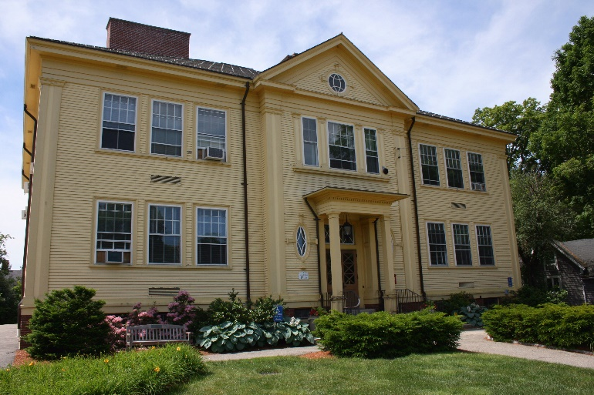Georgetown Town Hall (Photo Source Town of Georgetown)

Community safety
In 2016, the Town of Georgetown’s violent crime rate was 94% lower than the national average and 94% lower than the Massachusetts average. The property crime rate was 78% lower than the national average and 65% lower than the Massachusetts average.

Data Source: www.cityrating.com/crime-statistics

Transportation
Most resident of Georgetown rely on a car for transportation; I-95 runs through town and I-495 is easily accessible. Public Transportation in town is limited, however the town does have a Park & Ride bus service into Boston and the nearest Commuter Rail Station is in either Haverhill or Rowley.

Schools

Penn Brook Elementary School (K – 6)
Great Schools Rating: 6/10

Georgetown Middle School (7 – 8)
Great Schools Rating: 7/10

Georgetown High School (9 – 12)
Great Schools Rating: 7/10

Whittier Regional Vocational High School (9 – 12)
Great Schools Rating: 6/10

High School Graduation Rate
Georgetown High School | 99.0%
Massachusetts | 87.9%

Data Sources: GreatSchools.org; MA Dept. of Elementary & Secondary Education District Profiles

DEMOGRAPHICS
Poverty Rate: 3.4%

Race/Ethnicity | %
White | 96.7%
Asian | 1.9%
American Indian and Alaska Native | 0.1%
Hispanic or Latino | 3.8%
Black/African American | 1.4%
Native Hawaiian and Other Pacific Islander | 0.0%
Other | 1.2%

Age Group | %
Under 5 | 4.9%
Age 5-17 | 18.8%
Age 18-64 | 60.5%
Age 65 and older | 15.8%

Data Source: American FactFinder, U.S. Census Bureau

Local Amenities

While there are not many stores located within Georgetown, there are many shopping plazas in the surrounding cities and towns. Additionally, the Rockingham Mall in Salem, NH is only a short drive away.

The town of Georgetown has many outdoor recreation opportunities through its conservation areas and trail. The town also hold a Summer Concert series at their American Legion Field.

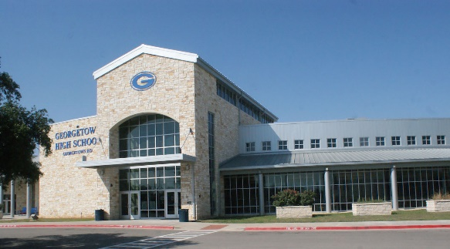
Georgetown High School (Photo Source: Community Impact)

MAP

