OVERVIEW
Groveland is a suburban community of 6,697 residents located just southwest of Haverhill in Essex County. The town’s history is rooted in the shoe and textile manufacturing industry, but now maintains many characteristics of a rural town. Most of the homes in Groveland are single-family homes; however, there are also multi-family units available.

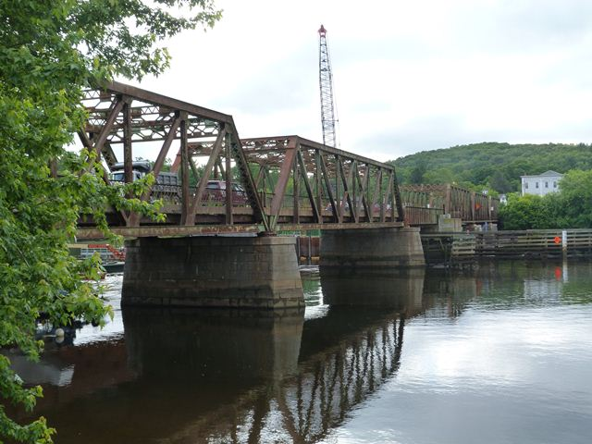Bates Bridge (Photo Source historicbridges.org)

Community safety
In 2016, the Town of Groveland’s violent crime rate was 93% lower than the national average and 92% lower than the Massachusetts average. The property crime rate was 93% lower than the national average and 90% lower than the Massachusetts average.

Data Source: www.cityrating.com/crime-statistics

Transportation
Most resident of Groveland rely on a car for transportation; both I-495 and I-95 are easily accessible. Public transportation service is not available in town, and the nearest Commuter Rail Station is in Haverhill.

Schools

Dr. Elmer S. Bagnall Elementary School (PK – 6)
Great Schools Rating: 3/10

Pentucket Regional Middle School (7 – 8)
Great Schools Rating: 4/10

Pentucket Regional High School (9 – 12)
Great Schools Rating: 8/10

Whittier Regional Vocational High School (9 – 12)
Great Schools Rating: 6/10

High School Graduation Rate
Pentucket Regional High School | 96.6%
Massachusetts | 87.9%

Data Sources: GreatSchools.org; MA Dept. of Elementary & Secondary Education District Profiles

DEMOGRAPHICS
Poverty Rate: 2.4%

Race/Ethnicity | %
White | 98.7%
Asian | 0.2%
American Indian and Alaska Native | 0.3%
Hispanic or Latino | 4.0%
Black/African American | 0.8%
Native Hawaiian and Other Pacific Islander | 0.0%
Other | 0.0%

Age Group | %
Under 5 | 3.4%
Age 5-17 | 18.1%
Age 18-64 | 62.1%
Age 65 and older | 16.4%

Data Source: American FactFinder, U.S. Census Bureau

Local Amenities

While there are not many stores located within Groveland, there are many shopping plazas in the surrounding cities and towns. Additionally, the Rockingham Mall in Salem, NH is only a short drive away.

The town of Groveland supports a variety of youth sports programs for members of the community and offers many outdoor recreation opportunities through its parks and conservation areas.

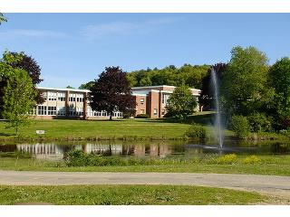
Pentucket Regional High School (Photo Source: School Spring)

MAP

