OVERVIEW
Haverhill is an urban community of 62,943 residents located just south of the New Hampshire border, and northeast of Lawrence. The City was originally a mill town known for manufacturing shoes, and it retains this character through its many mill buildings still located downtown. The city has a variety of housing options with families living in a mix of single-family, multi-family, and apartment homes.

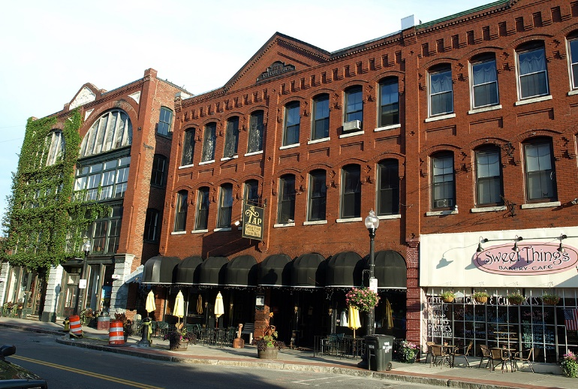Downtown Haverhill (Photo Source: Boston Magazine)

Community safety
In 2016, the City of Haverhill’s violent crime rate was 49% higher than the national average and 57% higher than the Massachusetts average. The property crime rate was 36% lower than the national average and 0% higher than the Massachusetts average.

Data Source: www.cityrating.com/crime-statistics

Transportation
Many residents of Haverhill rely on a car for transportation, I-495 runs through town and I-93 is easily accessible, however there are also public transportation options available. MVRTA 01, 13, 14, 15, 16, 18, and 51 buses serve the city, and the nearest Commuter Rail Station is within the City.

Schools

Bradford Elementary School (K – 5)
Great Schools Rating: 4/10

Golden Hill Elementary School (K – 4)
Great Schools Rating: 3/10

Pentucket Lake Elementary School (K – 4)
Great Schools Rating: 3/10

Silver Hill Elementary School (K – 5)
Great Schools Rating: 4/10

Tilton Elementary School (1 – 4)
Great Schools Rating: 2/10

Consentino Middle School (1 – 8)
Great Schools Rating: 4/10

Hunking Middle School (6 – 8)
Great Schools Rating: 3/10

Nettle Middle School (5 – 8)
Great Schools Rating: 4/10

Whittier Middle School (5 – 8)
Great Schools Rating: 4/10

Haverhill High School (9 – 12)
Great Schools Rating: 3/10

Whittier Regional Vocational High School (9 – 12)
Great Schools Rating: 6/10

High School Graduation Rate
Haverhill High School | 86.2%
Massachusetts | 87.9%

Data Sources: GreatSchools.org; MA Dept. of Elementary & Secondary Education District Profiles

DEMOGRAPHICS
Poverty Rate: 12.6%

Race/Ethnicity | %
White | 86.0%
Asian | 1.9%
American Indian and Alaska Native | 0.4%
Hispanic or Latino | 21.1%
Black/African American | 5.5%
Native Hawaiian and Other Pacific Islander | 0.2%
Other | 9.4%

Age Group | %
Under 5 | 7.1%
Age 5-17 | 16.2%
Age 18-64 | 64.2%
Age 65 and older | 12.5%
Data Source: American FactFinder, U.S. Census Bureau

Local Amenities

Within Haverhill, there are many shopping plazas and restaurants, including three supermarkets. Any errands that cannot be completed in town can be completed at the nearby Rockingham Mall in Salem, NH.

Outside of the city center, Haverhill has conserved open space, which offers access to recreational hiking trails and access to lakes, streams, ponds, and forests. Additionally, throughout the course of the year Haverhill hosts many festivals and provides many recreational opportunities for residents.

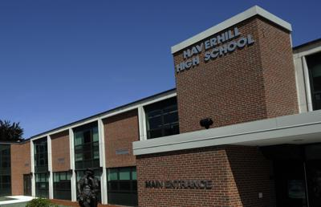
Haverhill High School (Photo Source: Eagle-Tribune)

MAP

