OVERVIEW
Ipswich is a community of 13,810 residents located north of Hamilton and south of Rowley in Essex County. The town was originally settled as a farming and fishing town, and has retained it small town charm. Many residents live in single-family homes; however, there are also multi-family homes available in town.

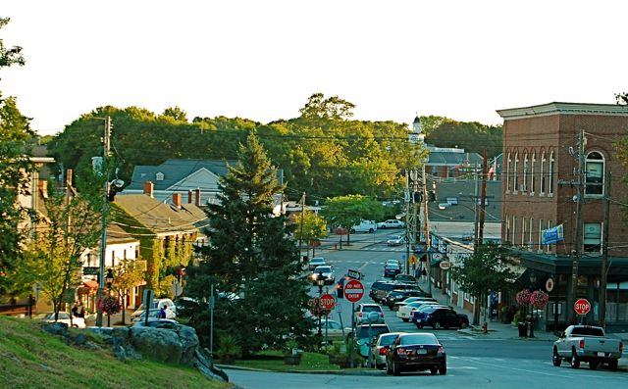Downtown Ipswich (Photo Source: Ipswich Chronicle)

Community safety
In 2016, the Town of Ipswich’s violent crime rate was 67% lower than the national average and 66% lower than the Massachusetts average. The property crime rate was 76% lower than the national average and 62% lower than the Massachusetts average.

Data Source: www.cityrating.com/crime-statistics

Transportation
Many residents of Ipswich rely on a car for transportation; I-95 is easily accessible from town. Public transportation in town is limited as there is no bus service. The nearest Commuter Rail Station is located in town.

Schools

Winthrop Elementary School (PK – 5)
Great Schools Rating: 6/10

Paul F. Doyon Memorial Elementary School (PK – 5)
Great Schools Rating: 6/10

Ipswich Middle School (6 – 8)
Great Schools Rating: 7/10

Ipswich High School (9 – 12)
Great Schools Rating: 7/10

Whittier Regional Vocational High School (9 – 12)
Great Schools Rating: 6/10

High School Graduation Rate
Ipswich High School | 99.1%
Massachusetts | 87.9%

Data Sources: GreatSchools.org; MA Dept. of Elementary & Secondary Education District Profiles

DEMOGRAPHICS
Poverty Rate: 7.1%

Race/Ethnicity | %
White | 97.3%
Asian | 0.9%
American Indian and Alaska Native | 0.3%
Hispanic or Latino | 3.1%
Black/African American | 1.2%
Native Hawaiian and Other Pacific Islander | 0.0%
Other | 1.2%

Age Group | %
Under 5 | 3.4%
Age 5-17 | 17.0%
Age 18-64 | 57.8%
Age 65 and older | 21.8%

Data Source: American FactFinder, U.S. Census Bureau

Local Amenities

The town of Ipswich has a few shopping centers, and restaurants; including two supermarkets. Any shopping trips that cannot be completed in town can be done in one of the surrounding towns.

Ipswich has an active Recreation Department and Cultural Council, which host a variety of events and fairs year round. Additionally, the town has many outdoor recreation opportunities at its many conservation areas and at its public beaches.

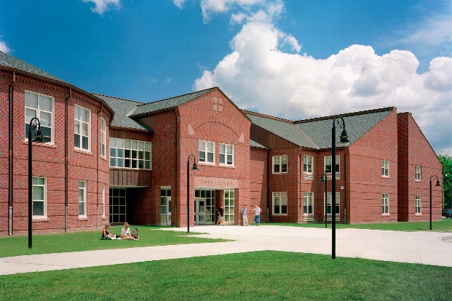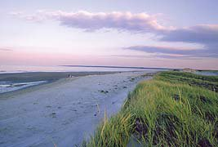
Ipswich High School (Photo Source: Flansburgh Architects) Crane Beach (Bostoncentral.com)

MAP

