OVERVIEW
Lynnfield is a suburban community of 12,732 residents located north of Saugus, and west of Peabody in Essex County. The town is primarily residential with business districts located along the highways. The majority of homes in town are single-family homes, but townhomes and apartments are also available.

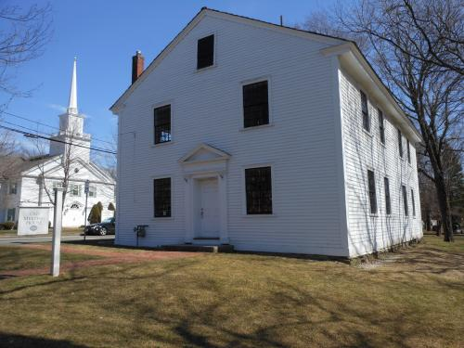Lynnfield Meetinghouse (Photo Source: Essex Heritage)

Community safety
In 2016, the Town of Lynnfield’s violent crime rate was 82% lower than the national average and 82% lower than the Massachusetts average. The property crime rate was 72% lower than the national average and 55% lower than the Massachusetts average.

Data Source: www.cityrating.com/crime-statistics

Transportation
Most residents of Lynnfield rely on a car for transportation; I-95 runs through town. Public transportation in town is limited. The nearest Commuter Rail Station is located in either Reading or Wakefield depending on what part of town you live in.

Schools

Summer Street Elementary School (K – 4)
Great Schools Rating: 9/10

Huckleberry Hill Elementary School (K – 4)
Great Schools Rating: 8/10

Lynnfield Middle School (5 – 8)
Great Schools Rating: 8/10

Lynnfield High School (9 – 12)
Great Schools Rating: 10/10

Essex Technical High School (9 – 12)
Great Schools Rating: 7/10

High School Graduation Rate
Lynnfield High School | 96.9%
Massachusetts | 87.9%

Data Sources: GreatSchools.org; MA Dept. of Elementary & Secondary Education District Profiles

DEMOGRAPHICS
Poverty Rate: 1.8%

Race/Ethnicity | %
White | 93.5%
Asian | 6.0%
American Indian and Alaska Native | 0.0%
Hispanic or Latino | 2.8%
Black/African American | 0.6%
Native Hawaiian and Other Pacific Islander | 0.0%
Other | 0.9%

Age Group | %
Under 5 | 4.8%
Age 5-17 | 18.9%
Age 18-64 | 55.7%
Age 65 and older | 20.6%

Data Source: American FactFinder, U.S. Census Bureau

Local Amenities

While there are not many stores or services located directly in Lynnfield, the Square One Mall is a short trip away in Saugus, MA. Many shopping trips can be completed nearby in the surrounding towns.

The Lynnfield Recreation Commission provides many programs and activities for residents, including sports. The town also provides many conservation areas, which provide space for outdoor recreation.

Lynnfield High School (Photo Source: Lynnfield Public Schools)

MAP

