OVERVIEW
Marblehead is a suburban community of 20,393 residents located east of Salem and along the Atlantic coast in Essex County. The town has a rich history dating back to the Revolutionary War, and the town retains much of that historical character. The housing in town is mixed between single-family homes and multi-family homes.

Downtown Marblehead (Photo Source: Yankee Magazine)

Community safety
In 2016, the Town of Marblehead’s violent crime rate was 73% lower than the national average and 72% lower than the Massachusetts average. The property crime rate was 71% lower than the national average and 54% lower than the Massachusetts average.

Data Source: www.cityrating.com/crime-statistics

Transportation
Many residents of Marblehead rely on a car for transportation; the town has easy access to I-95. MBTA 441 and 442 buses provide public transportation to town. The nearest Commuter Rail Station is located in Swampscott.

Schools

Glover Elementary School (PK – 3)
Great Schools Rating: No Rating

L.H. Coffin Elementary School (2 – 3)
Great Schools Rating: No Rating

Village School (4 – 6)
Great Schools Rating: 5/10

Marblehead Veterans Middle School (7 – 8)
Great Schools Rating: 6/10

Marblehead High School (9 – 12)
Great Schools Rating: 7/10

Essex Technical High School (9 – 12)
Great Schools Rating: 7/10

High School Graduation Rate
Marblehead High School | 96.8%
Massachusetts | 87.9%

Data Sources: GreatSchools.org; MA Dept. of Elementary & Secondary Education District Profiles

DEMOGRAPHICS
Poverty Rate: 4.6%

Race/Ethnicity | %
White | 96.2%
Asian | 2.0%
American Indian and Alaska Native | 0.1%
Hispanic or Latino | 3.5%
Black/African American | 1.8%
Native Hawaiian and Other Pacific Islander | 0.0%
Other | 0.6%

Age Group | %
Under 5 | 4.2%
Age 5-17 | 19.6%
Age 18-64 | 54.2%
Age 65 and older | 22.0%

Data Source: American FactFinder, U.S. Census Bureau

Local Amenities

There are some stores and shops within Marblehead, and any shopping that cannot be done in town can be done in one of the surrounding towns. Additionally, there are two malls nearby, the Square One Mall in Saugus, and the North Shore Mall in Peabody.

The town of Marblehead has many parks, playgrounds, and beaches, which provide many options for outdoor recreation activities. The town also sponsors many local youth sports and activities.

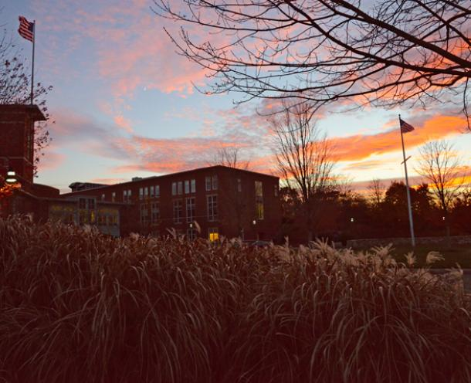
Marblehead High School (Photo Source: Marblehead Public Schools)

MAP

