OVERVIEW
Merrimac is a suburban community of 6,752 residents located east of Haverhill and just south of the New Hampshire border in Essex County. The town is located along the Merrimack River and maintains a rural feel. Most of the homes in Merrimac are single-family homes, however there are also multi-family homes and apartment complexes.

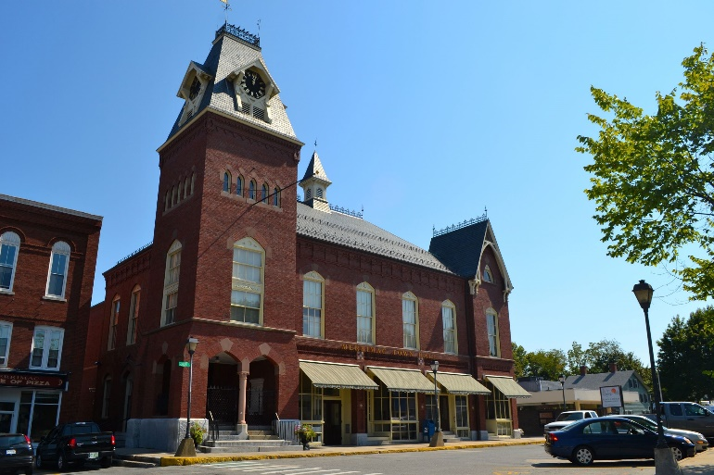Merrimac Town Hall (Photo Source: Town of Merrimac)

Community safety
In 2016, the Town of Merrimac’s violent crime rate was 74% lower than the national average and 73% lower than the Massachusetts average. The property crime rate was 78% lower than the national average and 65% lower than the Massachusetts average.

Data Source: www.cityrating.com/crime-statistics

Transportation
Most residents of Merrimac rely on a car for transportation; I-495 runs through town, and I-95 is easily accessible. MVRTA 52 bus provides public transportation to town. The nearest Commuter Rail Station is located in Haverhill.

Schools

Dr. Frederick N. Sweetsir School (PK – 2)
Great Schools Rating: No Rating

Helen R. Donaghue School (3 – 6)
Great Schools Rating: 4/10

Pentucket Regional Middle School (7 – 8)
Great Schools Rating: 4/10

Pentucket Regional High School (9 – 12)
Great Schools Rating: 8/10

Whittier Regional Vocational High School (9 – 12)
Great Schools Rating: 6/10

High School Graduation Rate
Pentucket Regional High School | 96.6%
Massachusetts | 87.9%

Data Sources: GreatSchools.org; MA Dept. of Elementary & Secondary Education District Profiles

DEMOGRAPHICS
Poverty Rate: 5.4%

Race/Ethnicity | %
White | 98.4%
Asian | 0.9%
American Indian and Alaska Native | 0.0%
Hispanic or Latino | 2.7%
Black/African American | 0.2%
Native Hawaiian and Other Pacific Islander | 0.0%
Other | 1.1%

Age Group | %
Under 5 | 3.2%
Age 5-17 | 16.5%
Age 18-64 | 61.0%
Age 65 and older | 19.3%

Data Source: American FactFinder, U.S. Census Bureau

Local Amenities

While there are not many stores within Merrimac, there are numerous shopping plazas in the surrounding cities and towns where errands can be completed.

Conveniently located along the Merrimack River, Merrimac offers many outdoor recreation opportunities along the river to go along with hiking trails and conservation areas in town.

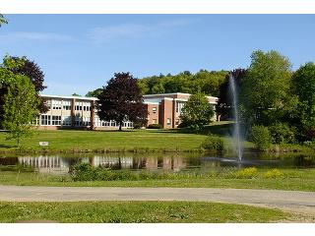
Pentucket Regional High School (Photo Source: School Spring)

MAP

