OVERVIEW
Methuen is an urban community of 47,299 residents located north of Lawrence and south of Salem, NH in Essex County. The City was formerly a mill town and has a history in manufacturing; much of this character has been retained. There is a mix of housing options in Methuen with many families living in single-family homes, multi-family homes, or apartment complexes.

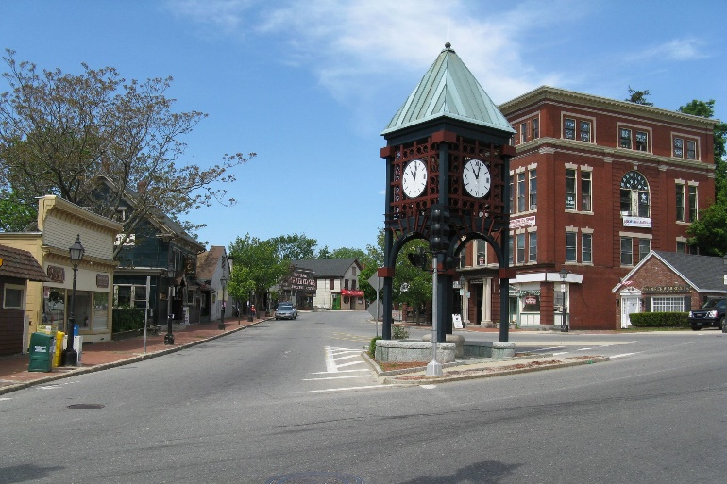Downtown Methuen (Photo Source: Century 21)

Community safety
In 2016, the Town of Methuen’s violent crime rate was 60% lower than the national average and 58% lower than the Massachusetts average. The property crime rate was 3% lower than the national average and 5% higher than the Massachusetts average.

Data Source: www.cityrating.com/crime-statistics

Transportation
Many residents of Methuen own a car as both I-495 and I-93 run through town; however, there are also many public transportation options. The MVRTA 01, 36, 40, and 99 buses serve the City. The nearest Commuter Rail Station is located in either Lawrence, or Haverhill.

Schools

Comprehensive Grammar School (PK – 8)
Great Schools Rating: 5/10

Marsh Grammar School (PK – 8)
Great Schools Rating: 6/10

Tenney Grammar School (PK – 8)
Great Schools Rating: 5/10

Timony Grammar School (PK – 8)
Great Schools Rating: 5/10

Methuen High School (9 – 12)
Great Schools Rating: 3/10

Greater Lawrence Technical High School (9 – 12)
Great Schools Rating: 4/10

High School Graduation Rate
Methuen High School | 91.5%
Massachusetts | 87.9%

Data Sources: GreatSchools.org; MA Dept. of Elementary & Secondary Education District Profiles

DEMOGRAPHICS
Poverty Rate: 9.4%

Race/Ethnicity | %
White | 80.5%
Asian | 4.2%
American Indian and Alaska Native | 1.5%
Hispanic or Latino | 27.2%
Black/African American | 6.0%
Native Hawaiian and Other Pacific Islander | 0.2%
Other | 10.8%

Age Group | %
Under 5 | 4.9%
Age 5-17 | 17.3%
Age 18-64 | 63.2%
Age 65 and older | 14.6%

Data Source: American FactFinder, U.S. Census Bureau

Local Amenities

Within Methuen, there are many shopping plazas and restaurants, including four supermarkets. Any shopping that cannot be completed in the City can be done at the Rockingham Mall in Salem, NH, which is only a short drive away.

The City of Methuen offers recreation opportunities for members of the community; these include youth sports leagues, as well as many parks and playgrounds. The city also hosts an annual Family Fall Festival.

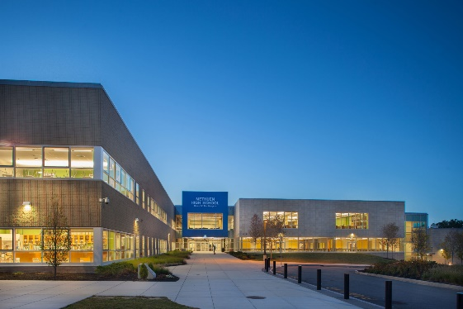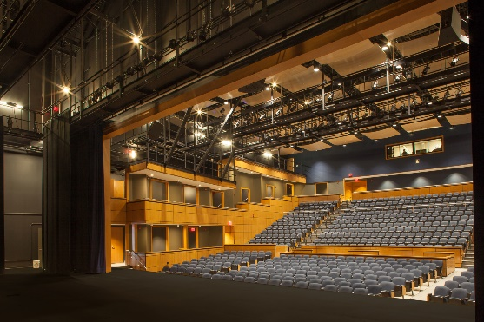
Methuen High School (Photo Source: Finegold Alexander Architects)

MAP

