OVERVIEW
Newbury is a community of 6,964 residents located just south of Newburyport on the seacoast in Essex County. The town is located along the Atlantic Ocean and includes part of Plum Island. The majority of houses in town are single-family homes.

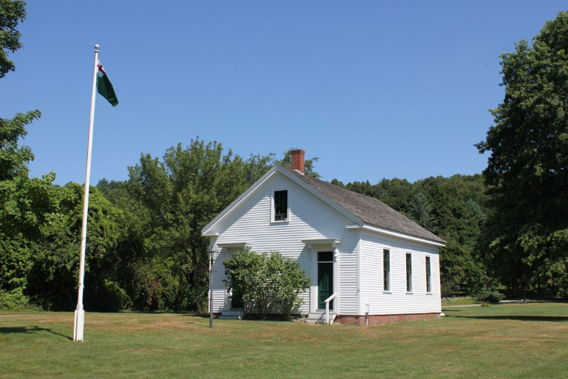Newbury Schoolhouse (Photo Source: Newbury1635.org)

Community safety
In 2016, the Town of Newbury’s violent crime rate was 57% lower than the national average and 55% lower than the Massachusetts average. The property crime rate was 84% lower than the national average and 75% lower than the Massachusetts average.

Data Source: www.cityrating.com/crime-statistics

Transportation
Most residents of Newbury rely on a car for transportation; I-95 runs through town, and I-495 is easily accessible. There is limited Public Transportation available in town, however they are served by the MVRTA Ring & Ride service. The nearest Commuter Rail Station is located in either Newburyport, or Rowley depending on what part of town you live.

Schools

Newbury Elementary School (PK – 6)
Great Schools Rating: 6/10

Triton Regional Middle School (7 – 8)
Great Schools Rating: 4/10

Triton Regional High School (9 – 12)
Great Schools Rating: 5/10

Whittier Regional Vocational High School (9 – 12)
Great Schools Rating: 6/10

High School Graduation Rate
Triton Regional High School | 92.9%
Massachusetts | 87.9%

Data Sources: GreatSchools.org; MA Dept. of Elementary & Secondary Education District Profiles

DEMOGRAPHICS
Poverty Rate: 4.2%

Race/Ethnicity | %
White | 97.5%
Asian | 0.8%
American Indian and Alaska Native | 0.2%
Hispanic or Latino | 2.6%
Black/African American | 1.4%
Native Hawaiian and Other Pacific Islander | 0.0%
Other | 0.5%

Age Group | %
Under 5 | 3.7%
Age 5-17 | 16.6%
Age 18-64 | 16.5%
Age 65 and older | 18.9%

Data Source: American FactFinder, U.S. Census Bureau

Local Amenities

Within town there are not many shopping plazas, however most shopping trips can be completed by commuting to one of the surrounding towns.

Newbury offers many outdoor recreation opportunities due to its location along the coast, including parts of Plum Island, and Plum Island State Park. The town also hosts community events including the Byfield Music & Arts Festival, and the Yankee Homecoming.

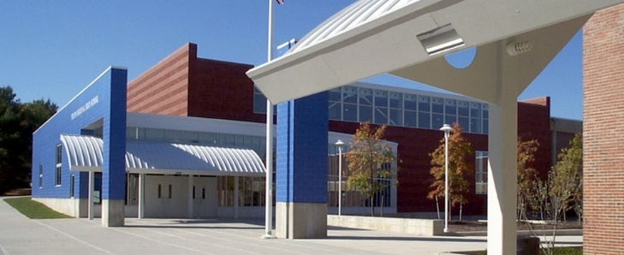
Triton Regional High School (Photo Source: Flansbugh Architects)

MAP

