OVERVIEW
Newburyport is a community of 17,890 residents along the seacoast and Merrimack River located just south of Salisbury in Essex County. The city was once known as a fishing, and shipping center, and maintains much of this character with its older buildings and brick facades downtown. The town has a mix of single-family and multi-family homes with many located near the downtown area.

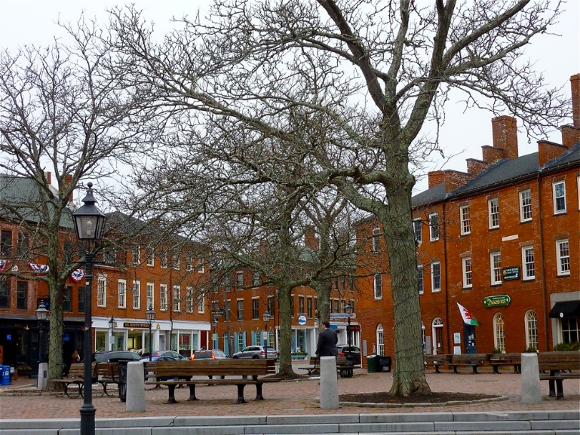Downtown Newburyport (Photo Source: Visiting New England)

Community safety
In 2016, the Town of Newburyport’s violent crime rate was 76% lower than the national average and 75% lower than the Massachusetts average. The property crime rate was 57% lower than the national average and 32% lower than the Massachusetts average.

Data Source: www.cityrating.com/crime-statistics

Transportation
Many residents of Newburyport rely on a car for transportation; I-95 runs through town and I-495 is easily accessible. MVRTA 54 bus provides public transportation to the city, and the nearest Commuter Rail Station is located within the city.

Schools

Francis T. Bresnahan Elementary School (PK – 3)
Great Schools Rating: 4/10

Edward G. Molin Upper Elementary School (4 – 5)
Great Schools Rating: 5/10

Rupert A. Nock Elementary School (6 – 8)
Great Schools Rating: 7/10

Newburyport High School (9 – 12)
Great Schools Rating: 7/10

Whittier Regional Vocational High School (9 – 12)
Great Schools Rating: 6/10

High School Graduation Rate
Newburyport High School | 96.7%
Massachusetts | 87.9%

Data Sources: GreatSchools.org; MA Dept. of Elementary & Secondary Education District Profiles

DEMOGRAPHICS
Poverty Rate: 7.0%

Race/Ethnicity | %
White | 95.0%
Asian | 2.7%
American Indian and Alaska Native | 0.2%
Hispanic or Latino | 2.0%
Black/African American | 1.8%
Native Hawaiian and Other Pacific Islander | 0.1%
Other | 1.2%

Age Group | %
Under 5 | 4.4%
Age 5-17 | 15.5%
Age 18-64 | 60.6%
Age 65 and older | 19.5%

Data Source: American FactFinder, U.S. Census Bureau

Local Amenities

Newburyport has a vibrant downtown area with many shops and restaurants, as well as three supermarkets in town. Many shopping trips can be completed in town, however surrounding cities and towns offer shopping plazas where you can complete your errands as well.

Conveniently located along the Merrimack River and on the Atlantic Ocean the town of Newburyport has many outdoor recreation options including public beaches on Plum Island as well nearby Plum Island State Park. In addition to the outdoor recreation options, the town also hosts cultural events year round including, the Winter Carnival, Newburyport Spring Festival, their Waterfront Movie Series, the Fall Harvest Festival and many others.

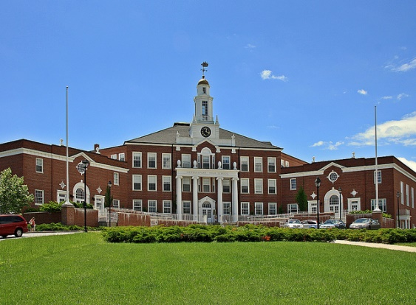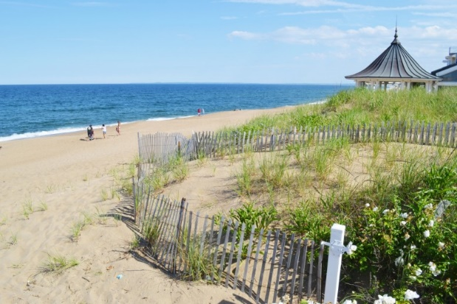
Newburyport High School (Photo Source: Newburyport.com) Plum Island Beach (Newengland.com)

MAP

