OVERVIEW
North Andover is a suburban community of 30,170 residents located southwest of Lawrence, and southeast of Haverhill. The town was formerly a mill town and retains much of that character. Most homes in North Andover are single-family homes, however there are also a mix of multi-family homes and apartment complexes.

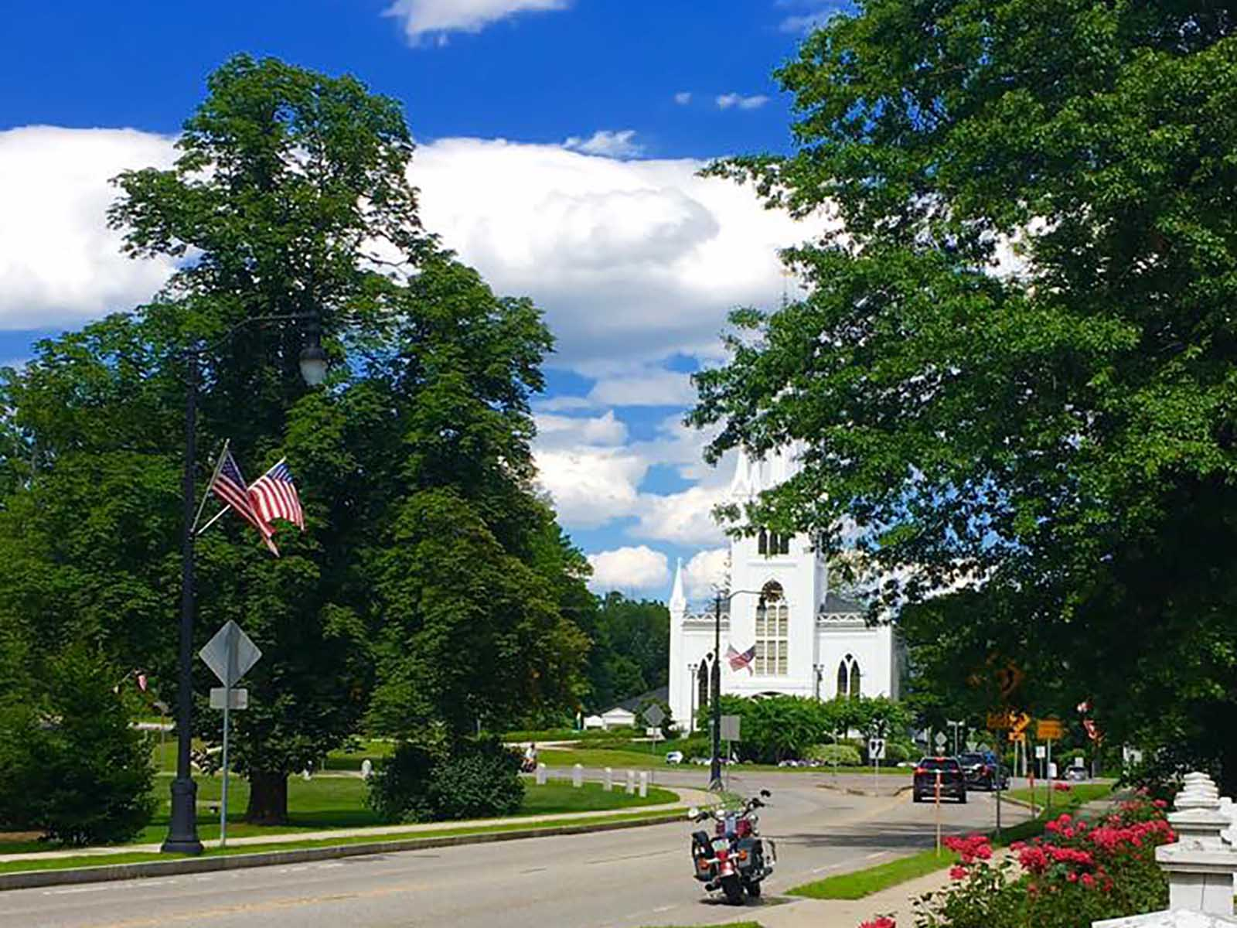North Parish Church (Photo Source: Merrimack Valley Real Estate)

Community safety
In 2016, the Town of North Andover’s violent crime rate was 90% lower than the national average and 89% lower than the Massachusetts average. The property crime rate was 76% lower than the national average and 62% lower than the Massachusetts average.

Data Source: www.cityrating.com/crime-statistics

Transportation
Most residents of North Andover rely on a car for transportation; I-495 runs through town and there is easy access to both I-93 and I-95. MVRTA 21, 33, 39A, 39B, and 98 buses provide public transportation for the town. The nearest Commuter Rail Station is located in either Lawrence, or Andover.

Schools

Atkinson Elementary School (PK – 5)
Great Schools Rating: 5/10

Franklin Elementary School (K – 5)
Great Schools Rating: 7/10

Kittredge Elementary School (K – 5)
Great Schools Rating: 7/10

Sargent Elementary School (K – 5)
Great Schools Rating: 5/10

Thomson Elementary School (K – 5)
Great Schools Rating: 5/10

North Andover Middle School (6 – 8)
Great Schools Rating: 7/10

North Andover High School (9 – 12)
Great Schools Rating: 7/10

Greater Lawrence Technical High School (9 – 12)
Great Schools Rating: 4/10

High School Graduation Rate
North Andover High School | 98.3%
Massachusetts | 87.9%

Data Sources: GreatSchools.org; MA Dept. of Elementary & Secondary Education District Profiles

DEMOGRAPHICS
Poverty Rate: 5.1%

Race/Ethnicity | %
White | 89.5%
Asian | 7.3%
American Indian and Alaska Native | 0.1%
Hispanic or Latino | 6.0%
Black/African American | 4.3%
Native Hawaiian and Other Pacific Islander | 0.0%
Other | 1.3%

Age Group | %
Under 5 | 5.6%
Age 5-17 | 18.6%
Age 18-64 | 61.7%
Age 65 and older | 14.5%
Data Source: American FactFinder, U.S. Census Bureau

Local Amenities

Within North Andover, there are many restaurants and shopping plazas, including two supermarkets. Any shopping that cannot be done in town can be done at the Rockingham Mall in Salem, NH.

The Town of North Andover offers many youth programs through the Stevens Memorial Library and through the Department of Youth Services, which operates over 40 programs.

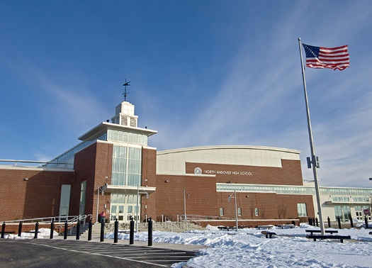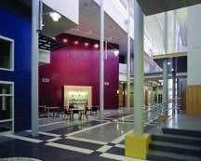
North Andover High School (Photo Source: Callahan-inc.com)

MAP

