OVERVIEW
Peabody is an urban community of 52,610 residents located west of Salem and north of Lynn in Essex County. The city was originally a farming town, which eventually attracted mills and specialized in the leather industry earning the nickname, “Tanner City”. There is a mix of housing in town with single-family, multi-family, and apartment homes available.

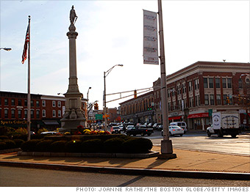Downtown Peabody (Photo Source: Boston Globe)

Community safety
In 2016, the City of Peabody’s violent crime rate was 1% lower than the national average and 4% higher than the Massachusetts average. The property crime rate was 47% lower than the national average and 16% lower than the Massachusetts average.

Data Source: www.cityrating.com/crime-statistics

Transportation
Many residents of Peabody use a car for transportation; I-95, and Route 1 run through the city. The MBTA 434, 435, and 465 buses provide public transportation. The nearest Commuter Rail Station is located in Salem.

Schools

Captain Samuel Brown Elementary School (K – 5)
Great Schools Rating: 3/10

John E. Burke Elementary School (K – 5)
Great Schools Rating: 6/10

Thomas Carroll Elementary School (K – 5)
Great Schools Rating: 5/10

Center Elementary School (K – 5)
Great Schools Rating: 6/10

John E. McCarthy Elementary School (PK – 5)
Great Schools Rating: 8/10

South Elementary School (PK – 5)
Great Schools Rating: 5/10

William A. Welch Elementary School (PK – 5)
Great Schools Rating: 4/10

West Memorial Elementary School (PK – 5)
Great Schools Rating: 5/10

J. Henry Higgins Middle School (6 – 8)
Great Schools Rating: 5/10

Peabody Veterans Memorial High School (9 – 12)
Great Schools Rating: 4/10

Essex Technical High School (9 – 12)
Great Schools Rating: 7/10

High School Graduation Rate
Peabody Veterans Memorial High School | 86.3%
Massachusetts | 87.9%

Data Sources: GreatSchools.org; MA Dept. of Elementary & Secondary Education District Profiles

DEMOGRAPHICS
Poverty Rate: 9.8%

Race/Ethnicity | %
White | 92.2%
Asian | 1.6%
American Indian and Alaska Native | 0.5%
Hispanic or Latino | 9.3%
Black/African American | 4.9%
Native Hawaiian and Other Pacific Islander | 0.1%
Other | 3.3%

Age Group | %
Under 5 | 5.8%
Age 5-17 | 11.6%
Age 18-64 | 61.7%
Age 65 and older | 20.9%
Data Source: American FactFinder, U.S. Census Bureau

Local Amenities
Within Peabody, there are many shopping plazas and restaurants; most errands can be completed in town. Additionally, the North Shore Mall is located in town.

The City of Peabody is also home to more than 20 parks and playgrounds providing ample space for outdoor activities. The town also hosts a Summer Concert Series, Farmer’s Market, Downtown Stroll and Annual Tree Lighting, and a Holiday Concert.

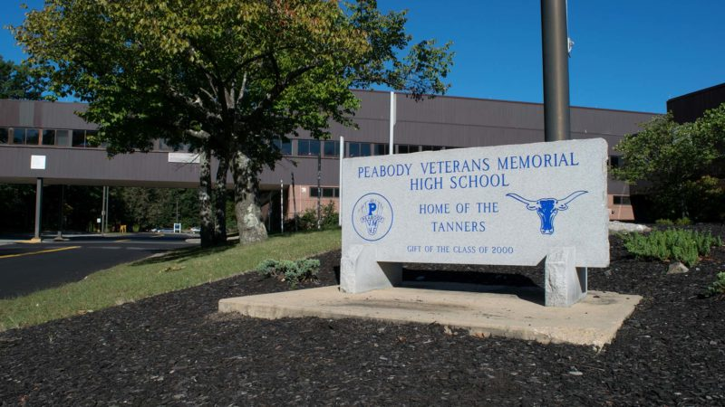
Peabody Veterans Memorial High School (Photo Source: Peabody Public Schools)

MAP

