OVERVIEW
Saugus is a suburban community of 28,037 residents located just north of Revere, and west of Lynn in Essex County. The town was home to the first integrated Ironworks in North America, and the site is now preserved as a National Historical Site. The housing in town is mixed between single-family homes and apartment complexes.

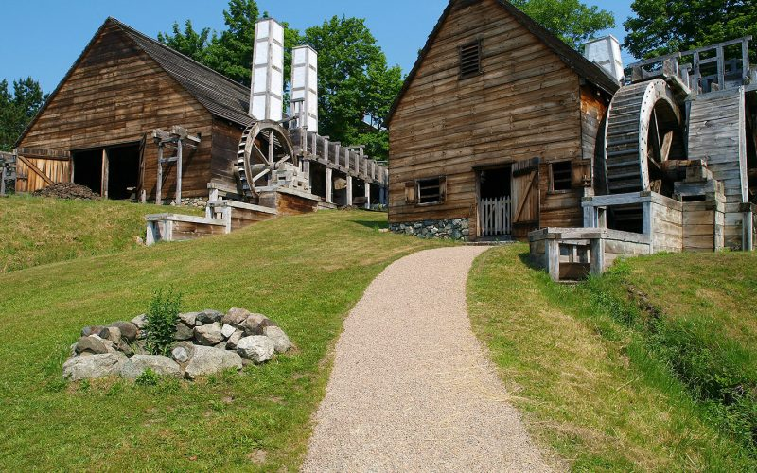Saugus Ironworks National Historical Site
(Photo Source: northofboston.org)

Community safety
In 2016, the Town of Saugus’ violent crime rate was 19% lower than the national average and 14% lower than the Massachusetts average. The property crime rate was 17% lower than the national average and 30% higher than the Massachusetts average.

Data Source: www.cityrating.com/crime-statistics

Transportation
Most residents of Saugus rely on a car for transportation; I-95 runs through town. The MBTA 428, 430, and 429 buses provide public transportation to town. The nearest Commuter Rail Station is located in Melrose, or Lynn depending on what part of town you live in.

Schools

Waybright Elementary School (K – 5)
Great Schools Rating: 9/10

Veterans Memorial Elementary School (K – 5)
Great Schools Rating: 5/10

Oaklandvale Elementary School (K – 5)
Great Schools Rating: 6/10

Lynnhurst Elementary School (K – 5)
Great Schools Rating: 6/10

Belmonte Saugus Middle School (6 – 8)
Great Schools Rating: 5/10

Saugus High School (9 – 12)
Great Schools Rating: 3/10

Northeast Metro Regional Vocational High School (9 – 12)
Great Schools Rating: 5/10

High School Graduation Rate
Saugus High School | 87.8%
Massachusetts | 87.9%

Data Sources: GreatSchools.org; MA Dept. of Elementary & Secondary Education District Profiles

DEMOGRAPHICS
Poverty Rate: 8.1%

Race/Ethnicity | %
White | 91.8%
Asian | 4.9%
American Indian and Alaska Native | 0.5%
Hispanic or Latino | 4.8%
Black/African American | 3.6%
Native Hawaiian and Other Pacific Islander | 0.0%
Other | 0.5%

Age Group | %
Under 5 | 4.2%
Age 5-17 | 13.7%
Age 18-64 | 62.5%
Age 65 and older | 19.6%

Data Source: American FactFinder, U.S. Census Bureau

Local Amenities

There are many stores and shopping centers within Saugus, including the Square One Mall. Most shopping trips can be completed without leaving town.

The town of Saugus has preserved many outdoor and historical areas, which provide recreational opportunities to the town’s residents.

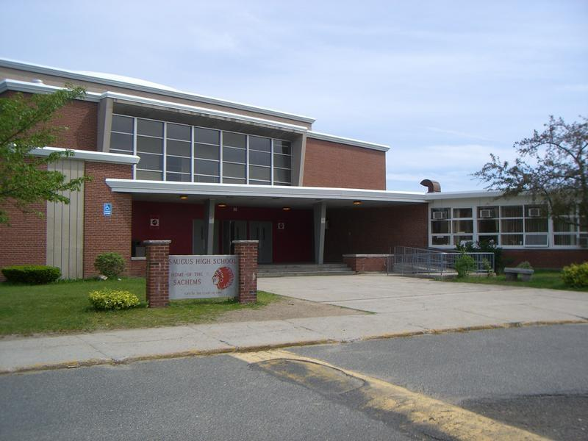
Saugus High School (Photo Source: Saugus Wicked Local)

MAP

