OVERVIEW
Swampscott is a suburban community of 14,563 residents located just east of Lynn and along the Atlantic coast in Essex County. The town was originally a fishing village, and has transformed into a quiet residential community. The housing in town is mixed between single-family homes, multi-family homes, and apartment complexes.

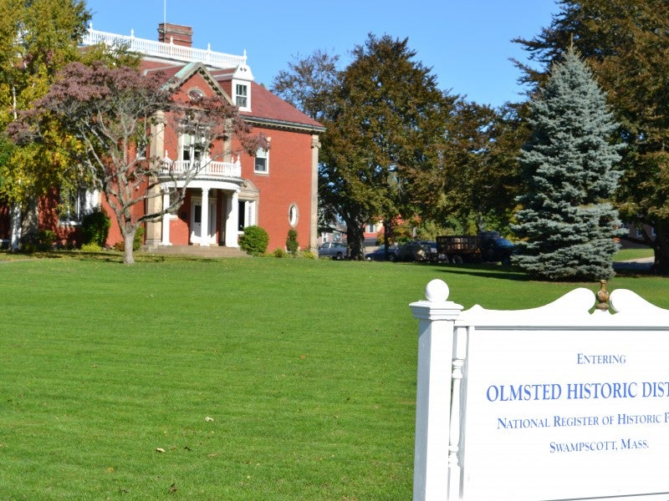Swampscott Town Hall (Photo Source: patch.com)

Community safety
In 2016, the Town of Swampscott’s violent crime rate was 83% lower than the national average and 82% lower than the Massachusetts average. The property crime rate was 48% lower than the national average and 18% lower than the Massachusetts average.

Data Source: www.cityrating.com/crime-statistics

Transportation
Many residents of Swampscott rely on a car for transportation; the town has easy access to I-95. The MBTA 441 and 442 buses serve the town. The nearest Commuter Rail Station is located in town.

Schools

Clarke Elementary School (K – 4)
Great Schools Rating: 4/10

Hadley Elementary School (K – 4)
Great Schools Rating: 7/10

Stanley Elementary School (K – 4)
Great Schools Rating: 6/10

Swampscott Middle School (5 – 8)
Great Schools Rating: 6/10

Swampscott High School (9 – 12)
Great Schools Rating: 8/10

Essex Technical High School (9 – 12)
Great Schools Rating: 7/10

High School Graduation Rate
Swampscott High School | 98.6%
Massachusetts | 87.9%

Data Sources: GreatSchools.org; MA Dept. of Elementary & Secondary Education District Profiles

DEMOGRAPHICS
Poverty Rate: 6.1%

Race/Ethnicity | %
White | 98.0%
Asian | 1.8%
American Indian and Alaska Native | 0.2%
Hispanic or Latino | 3.5%
Black/African American | 2.4%
Native Hawaiian and Other Pacific Islander | 0.5%
Other | 0.6%

Age Group | %
Under 5 | 7.7%
Age 5-17 | 15.8%
Age 18-64 | 56.9%
Age 65 and older | 19.6%

Data Source: American FactFinder, U.S. Census Bureau

Local Amenities

There are many stores and shopping centers within Swampscott, including four supermarkets. Any shopping trips that cannot be completed in town can be done at the nearby Square One Mall in Saugus, or North Shore Mall in Peabody.

The town of Swampscott organizes many youth sports along with preserving parks, and playground, which provide recreational opportunities for residents. Swampscott is also located along the Atlantic coast with many beaches open to the public.

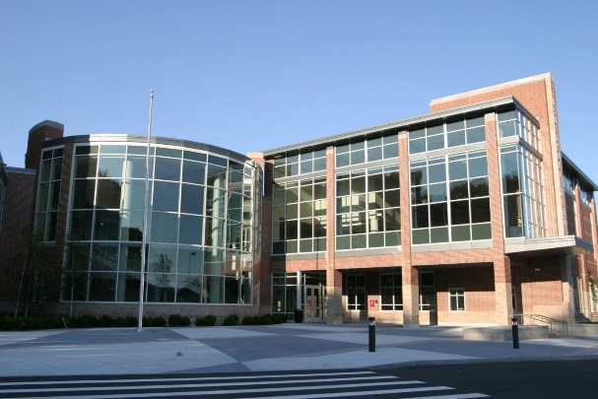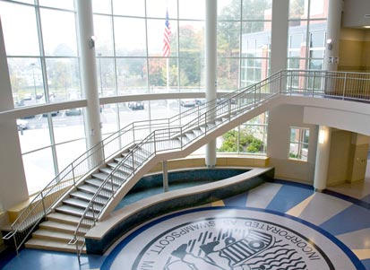
Swampscott High School (Photo Source: Swampscott Public Schools/quinniron.com)

MAP

