OVERVIEW
Tewksbury is a suburban community with a population of 30,666 located east of Lowell and west of Andover in Middlesex County. The town has a mix of residential neighborhoods as well as a commercial and retail base. Many of the homes are single-family homes; however, they also have many multi-family homes and apartment complexes.

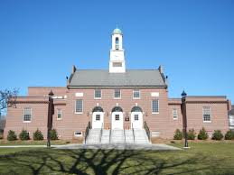Tewksbury Town Hall (Photo Source Town of Tewksbury)

Community safety
In 2016, the Town of Tewksbury’s violent crime rate was 49% lower than the national average and 46% lower than the Massachusetts average. The property crime rate was 61% lower than the national average and 38% lower than the Massachusetts average.

Data Source: www.cityrating.com/crime-statistics

Transportation
Most residents of Tewksbury rely on a car for transportation; both I-495 and I-93 run through town, and Route 3 is easily accessible. The LRTA 12 bus provides Public Transportation. The nearest Commuter Rail Station is located in either Billerica, Wilmington, or Andover depending on what part of Tewksbury you live.

Schools

Heath Brook Elementary School (K – 2)
Great Schools Rating: No Rating

Louise Davy Trahan Elementary School (3 – 4)
Great Schools Rating: 8/10

Loella F. Dewing Elementary School (PK – 2)
Great Schools Rating: No Rating

North Street Elementary School (3 – 4)
Great Schools Rating: 5/10

John F. Ryan Elementary School (5 – 6)
Great Schools Rating: 4/10

John W. Wynn Middle School (7 – 8)
Great Schools Rating: 7/10

Tewksbury Memorial High School (9 – 12)
Great Schools Rating: 5/10

Shawsheen Valley Technical High School (9 – 12)
Great Schools Rating: 7/10

High School Graduation Rate
Tewksbury Memorial High School | 95.0%
Massachusetts | 87.9%

Data Sources: GreatSchools.org; MA Dept. of Elementary & Secondary Education District Profiles

DEMOGRAPHICS
Poverty Rate: 5.4%

Race/Ethnicity | %
White | 93.7%
Asian | 4.4%
American Indian and Alaska Native | 0.4%
Hispanic or Latino | 1.6%
Black/African American | 2.3%
Native Hawaiian and Other Pacific Islander | 0.0%
Other | 0.6%

Age Group | %
Under 5 | 4.6%
Age 5-17 | 15.1%
Age 18-64 | 16.8%
Age 65 and older | 17.5%
Data Source: American FactFinder, U.S. Census Bureau

Local Amenities

Within Tewksbury, there are many shopping plazas, and there are three supermarkets; most errands can be completed in town. Any shopping that cannot be done in Tewksbury can be done at the Burlington Mall, which is only a short drive away.

The Town of Tewksbury offers many sports and recreation programs for the community. Additionally, over 15% of the town is conserved as either parks or open space and offer the public many outdoor recreation options.

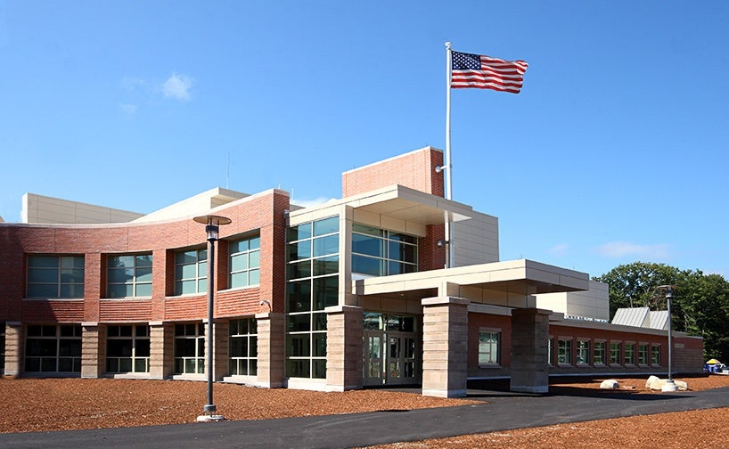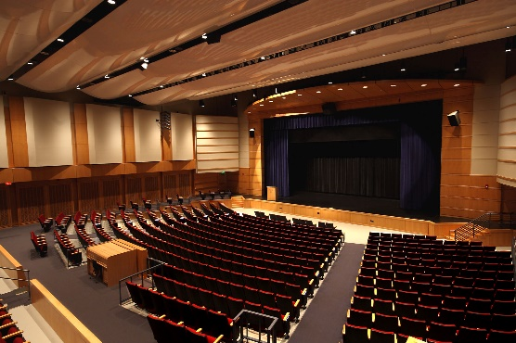
Tewksbury High School (Photo Source: Patch.com/ctaconstruction.com)

MAP

