OVERVIEW
Topsfield is a rural community of 6,496 residents located south of Boxford and west of Hamilton in Essex County. The town was originally a farming town and still has many farms in operation. The town retains a rural character. Most families in town live in single-family homes.

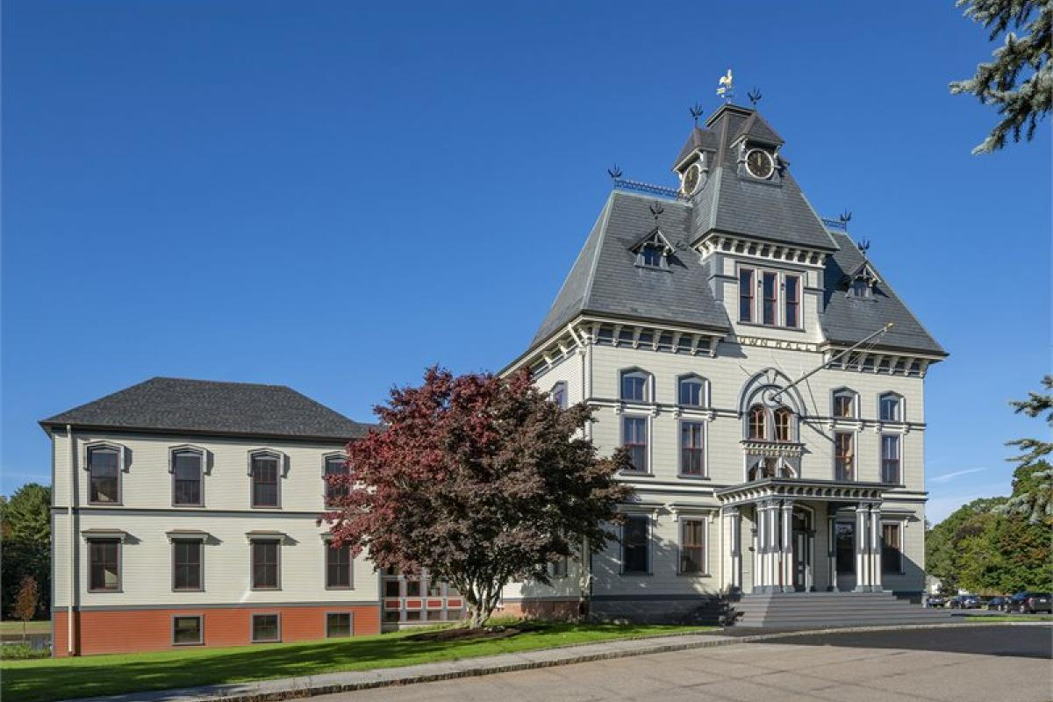Topsfield Town Hall (Photo Source: Town of Topsfield)

Community safety
In 2016, the Town of Topsfield’s violent crime rate was 89% lower than the national average and 88% lower than the Massachusetts average. The property crime rate was 93% lower than the national average and 89% lower than the Massachusetts average.

Data Source: www.cityrating.com/crime-statistics

Transportation
Most residents of Topsfield rely on a car for transportation; I-95 runs through town. Public Transportation is limited in town, however, there is a Park & Ride bus service into Boston, and the nearest Commuter Rail Station is in Hamilton.

Schools

Steward Elementary School (PK – 3)
Great Schools Rating: No Rating

Proctor Elementary School (4 – 6)
Great Schools Rating: 7/10

Masconomet Regional Middle School (7 – 8)
Great Schools Rating: 7/10

Masconomet Regional High School (9 – 12)
Great Schools Rating: 9/10

Essex Technical High School (9 – 12)
Great Schools Rating: 7/10

High School Graduation Rate
Masconomet Regional High School | 99.3%
Massachusetts | 87.9%

Data Sources: GreatSchools.org; MA Dept. of Elementary & Secondary Education District Profiles

DEMOGRAPHICS
Poverty Rate: 1.4%

Race/Ethnicity | %
White | 97.0%
Asian | 3.3%
American Indian and Alaska Native | 0.0%
Hispanic or Latino | 1.3%
Black/African American | 0.2%
Native Hawaiian and Other Pacific Islander | 0.0%
Other | 0.3%

Age Group | %
Under 5 | 4.1%
Age 5-17 | 20.5%
Age 18-64 | 52.3%
Age 65 and older | 23.1%

Data Source: American FactFinder, U.S. Census Bureau

Local Amenities

While there are not many stores or services located directly in Topsfield, the surrounding towns have several shopping plazas where most shopping trips can be completed.

The town has many outdoor recreation opportunities including a town beach at Hood Pond. The town also hosts the Topsfield Fair annually; this is a large agricultural fair.

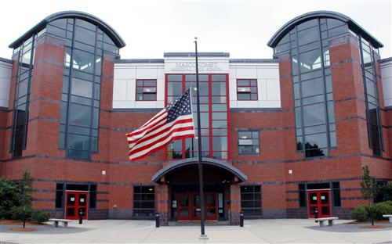
Masconomet Regional High School (Photo Source: Masconomet Regional School District)

MAP

