OVERVIEW
Wenham is a suburban community of 4,875 residents located just south of Hamilton, and north of Beverly in Essex County. The town has retained a historic and rural character with many farms, lakes and forests. Wenham shares many of its services with neighboring Hamilton. The majority of residents live in single-family homes, other options for housing are limited.

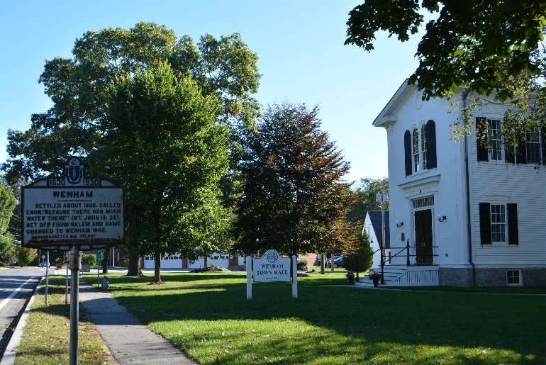Wenham Town Hall (Photo Source: Town of Wenham)

Community safety
In 2016, the Town of Wenham’s violent crime rate was 71% lower than the national average and 69% lower than the Massachusetts average. The property crime rate was 91% lower than the national average and 86% lower than the Massachusetts average.

Data Source: www.cityrating.com/crime-statistics

Transportation
Most residents of Wenham rely on a car for transportation; I-95 is easily accessible from town. Public Transportation in town is limited; however, the town does have its own Commuter Rail Station located in Hamilton or Beverly depending on what part of town you live in.

Schools

Buker Elementary School (K – 5)
Great Schools Rating: 6/10

Miles River Middle School (6 – 8)
Great Schools Rating: 8/10

Hamilton-Wenham Regional High School (9 – 12)
Great Schools Rating: 9/10

Essex Technical High School (9 – 12)
Great Schools Rating: 7/10

High School Graduation Rate
Hamilton-Wenham Regional High School | 95.9%
Massachusetts | 87.9%

Data Sources: GreatSchools.org; MA Dept. of Elementary & Secondary Education District Profiles

DEMOGRAPHICS
Poverty Rate: 1.7%

Race/Ethnicity | %
White | 93.9%
Asian | 3.3%
American Indian and Alaska Native | 0.1%
Hispanic or Latino | 4.7%
Black/African American | 2.2%
Native Hawaiian and Other Pacific Islander | 0.0%
Other | 1.4%

Age Group | %
Under 5 | 3.3%
Age 5-17 | 14.7%
Age 18-64 | 66.2%
Age 65 and older | 15.8%

Data Source: American FactFinder, U.S. Census Bureau

Local Amenities

The town of Wenham has a few shopping centers and restaurants in town; including one supermarket. Any shopping trips that cannot be completed in town can be done in one of the surrounding towns.

Hamilton-Wenham Recreation sponsors many youth programs including sports, and many other activities. The town also hosts local events such as their annual Pumpkin Fest.

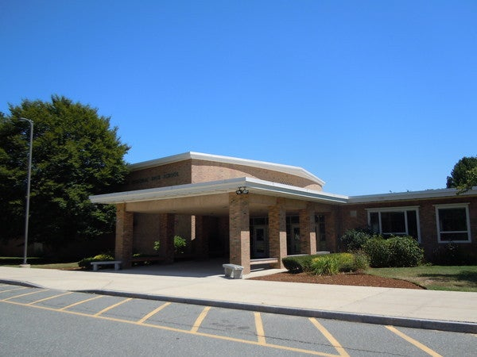
Hamilton-Wenham Regional High School (Photo Source: Hamilton Patch)

MAP

