OVERVIEW
West Newbury is a suburban community of 4,545 residents located east of Haverhill and west of Newburyport in Essex County. The town is located along the Merrimack River and is only a short drive to the ocean. Most of the homes in town are single-family homes, however some multi-family homes are available as well.

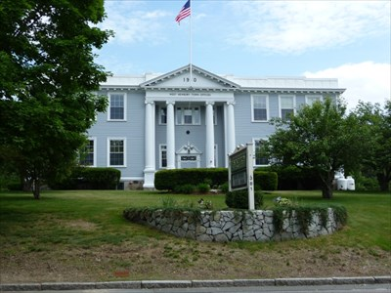West Newbury Town Hall (Photo Source: Waymarking)

Community safety
In 2016, the Town of West Newbury’s violent crime rate was 95% lower than the national average and 94% lower than the Massachusetts average. The property crime rate was 78% lower than the national average and 65% lower than the Massachusetts average.

Data Source: www.cityrating.com/crime-statistics

Transportation
Most residents of West Newbury rely on a car for transportation; I-95 runs through town and I-495 is easily accessible. There is no public transportation in town, and the nearest Commuter Rail Station is in either Newburyport, or Haverhill depending on what part of town you live in.

Schools

Dr. John C. Page School (PK – 6)
Great Schools Rating: 5/10

Pentucket Regional Middle School (7 – 8)
Great Schools Rating: 4/10

Pentucket Regional High School (9 – 12)
Great Schools Rating: 8/10

Whittier Regional Vocational High School (9 – 12)
Great Schools Rating: 6/10

High School Graduation Rate
Pentucket Regional High School | 96.6%
Massachusetts | 87.9%

Data Sources: GreatSchools.org; MA Dept. of Elementary & Secondary Education District Profiles

DEMOGRAPHICS
Poverty Rate: 5.7%

Race/Ethnicity | %
White | 99.1%
Asian | 1.2%
American Indian and Alaska Native | 0.3%
Hispanic or Latino | 1.0%
Black/African American | 0.0%
Native Hawaiian and Other Pacific Islander | 0.0%
Other | 0.1%

Age Group | %
Under 5 | 4.8%
Age 5-17 | 20.3%
Age 18-64 | 59.0%
Age 65 and older | 15.9%

Data Source: American FactFinder, U.S. Census Bureau

Local Amenities

While there are not many stores within West Newbury, there are numerous shopping plazas in the surrounding cities and towns where errands can be completed.

Conveniently located along the Merrimack River, West Newbury offers many outdoor recreation opportunities along the river to go along with other trails and conservation areas in town.

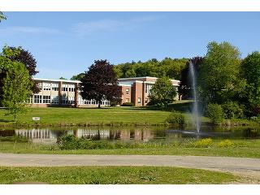
Pentucket Regional High School (Photo Source: School Spring)

MAP

