Mayor’s Holiday Fest for Homeless Youth
3rd Annual Rock n’ Roll Fundraiser

Tickets $20 / Person $10 / Student Must be 21+
Sponsor Opportunities
Gold Sponsor $1,000
- Logo displayed on CTI Mayor’s Holiday Fest website and special inclusion in newspaper and radio coverage
- Check presentation photo op: will also appear on commteam.org
- Logo displayed at Event and on Event Program
- Mention from podium and on all social media
- 10 Complimentary Tickets to the Show
- Eligible for Community Tax Credit (CITC) - eligible for 50% credit/refund
Silver Sponsor $ 500
- Check presentation photo op: will also appear on commteam.org
- Logo displayed at Event and on Event Program
- Mention from podium and on all social media
- 5 Complimentary Tickets to the Show
Bronze Sponsor $ 250
- Logo displayed at Event and on Event Program
- Mention from podium and on all social media
- 2 Complimentary Tickets to the Show
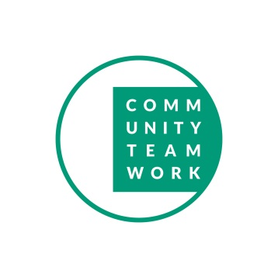
All proceeds from the event will be donated to Community Teamwork Incorporated (CTI)
Mayor’s Fund to End Youth Homelessness
#LowellYouthHousing #LowellYouthSpeak
www.commteam.org/mayorsholidayfest

