Lowell Farmers’ Market 2020
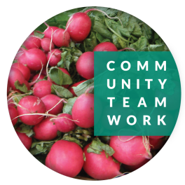
Fridays, 12:00pm-5:00pm
July 10 - October 2
Lucy Larcom Park, 258 Merrimack Street
www.commteam.org/farmers-market
www.facebook.com/LowellFarmersMarket
February 14, 2019

Dear Prospective/Returning Vendor:

Welcome to the 2020 Farmers’ Market season! We'd like express our appreciation for all that you do to help make our market a profitable and fun place to be. If you're joining us for the first time, we'd like to welcome you to our family of hard-working, friendly vendors. You can count on us to do everything we can to help you get established so that you can successfully market your products to our ever-growing base of loyal customers. In addition to addressing the needs of our vendors and customers, Community Teamwork will advertise and promote the market, keep you abreast of changes and announcements, and will coordinate our vendors' participation in the Supplemental Nutrition Assistance (SNAP/EBT) and Healthy Incentives Program (HIP) for this market season. This market accepts Visa, MasterCard, and Discover credit/debit cards. We appreciate all of our vendors who are committed to participate in these programs.
Attached to this letter, please find our 2020 Vendor Contract and Application. This year we have made a couple of small changes to the application, so please read carefully.

Kick-off on Friday, July 10th this year, and we will continue through until the beginning of October. The market will be open from 12pm to 5pm, and will be at the same location as last year. Lucy Larcom Park (258 Merrimack Street, Lowell MA 01852).

Payments: This packet contains a new vendor agreement. Please note changes that you may or may not have noticed last year that are critical to transparency for the customer. Please make checks payable to Community Teamwork. For those who would rather pay at the market, as you go, we’ll collect by cash, check or charge on market day toward the end.

Checklist to sign up for the market:
- Reviewed and signed original Vendor Application and Contract. Keep a copy of the agreement for your files. Return the original.
- Prepayment check if applicable made out to Community Teamwork Inc.
- Inventory summary with dates that you will attend (one page)
- Copy of proof of insurance

Mail pages back to 45 Kirk St or drop off to Deb at the front desk of 17 Kirk Street, Lowell MA 01852.

Please let me know how we can help and support you.

Warmest,

Susan Brittain
Lowell Farmers’ Market
Community Teamwork
sbrittain@commteam.org
(978) 654-4905

