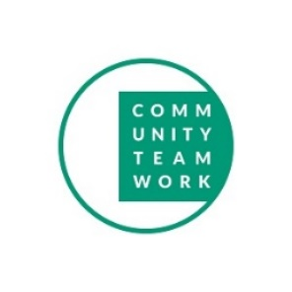
COVID-19
EMERGENCY RESPONSE

Community Teamwork is here to help…
During this health crisis, Community Teamwork has put in place emergency programming to ensure that we can continue to provide critical service to our clients while maintaining social distancing protocols for the health and safety of our community, our clients and our Community Teamwork staff. While we are closing all our buildings to walk-in traffic, our staff is available by phone, email and, in extreme circumstances, to meet with clients on an appointment-only basis. Please call one of the numbers below and our staff will work with you to find the right solutions for you and your family during this challenging time.
Resource Center
Our Resource Center and Housing Consumer Education Center (HCEC) have cancelled all individual meetings, workshops and trainings until further notice. However, all of our staff will be available via phone and email.
The Majority of our emergency services are accessible via phone or email.
We will be using an emergency COVID hotline and general mailbox which will be continuously monitored from 8:30am to 5pm every weekday. We will work to ensure that all calls and emails will receive a response within 2 hours. All emergency contact information on and additional email address information is also available on our website www.commteam.org
Emergency Contact Information
Resource Center and HCEC  (for all general emergency referrals) | 978.654.5607 | CovidResponseCTI@commteam.org
Fuel Assistance and Heating System Repair  (Please note: As long as the State of Emergency is in effect the Department of Public Utilities has extended the moratorium that all utilities must follow the “no shut off” rule.) | 978.459.6161 | FuelAssistance@commteam.org
WIC | 978.454.6397 | WICCovidResponseCTI@commteam.org
Rental Assistance (Section 8 & MRVP) | 978.654.5726 | CTIRentalAssistance@commteam.org
Youth Services | 978.905.7385 | CTIYouthServices@commteam.org
Child and Family Services | 978.454.5100 | ChildcareCovidCTI@commteam.org

Updated 3.23.2020

