All this snow!! Here is the Sledding Guide from Macaroni Kids. Please keep safety in mind at all times. Sledding is fun, but accidents do happen. Adult supervision is needed.
Also on our Winter Activities Parent Board
https://padlet.com/gmfbog/5gq9dgpq0zl7mejk
Local Sledding Guide from Lowell Macaroni Kid
By Christine Zarzicki & Barbara Evangelista November 30, 2020
1
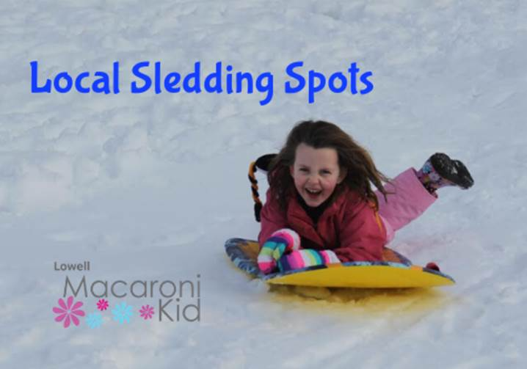
Approaching snow storms mean more than visions of a pristine winter wonderland... they mean copious amounts of shoveling and SCHOOL CLOSINGS! And while every child eagerly waits to hear the words “school is closed today”, every mom is thinking “what the heck are we going to do all day?!” Fortunately, there is no shortage of sledding hills nearby. There are short and shallow hills that are ideal for the little ones, tubing parks with groomed long trails, and hair-raising steep hills that older kids will love.
Tips for your next sledding trip:
- Arrive early as parking spots fill quickly.
- Sledders should wear helmets if at all possible and snow pants to stay warm
- Bring extra mittens or gloves to replace wet ones
- Hand and toe warmer packets can be purchased at pharmacies and hardware stores

ACTON
NARA Park, 25 Ledge Rock Way. Park in the lot on Quarry Rd. Long, steep hills make for thrilling sledding! Sled ramps are not allowed.
Benjamin Hill, on Benjamin Road
BEDFORD
Davis Elementary School, 410 Davis Road. Small hill, best for littles.
BOXBOROUGH
Steele Farm, Middle Road. Snowshoeing trails also available.
BURLINGTON
Simonds Park, 10 Bedford St.
CHELMSFORD
Varney Park, 45 Varney Ave, North Chelmsford
South Row School, 250 Boston Rd
Byam School, 25 Maple Rd
CONCORD
Nashawtuc Hill, Nashawtuc Rd. Large and steep hill.

