Celebrate Valentine's Day with this beautiful and fun Valentine Heart Suncatcher Craft. This suncatcher craft for kids is the perfect way to dress up your windows this Valentine's Day or just anytime you want to add something fun your kids made. Be sure to download the Free Suncatcher Hearts Printable here!

15 to 25 min. Beginner
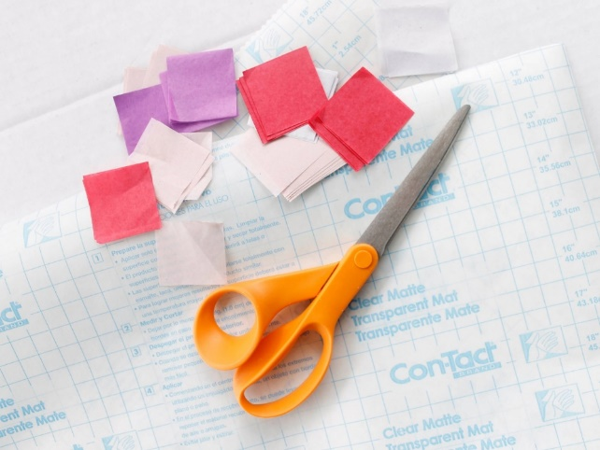

STEP 1
Cut 2 pieces of contact paper about 11x18" long.

STEP 2
Start placing pieces of mini tissue paper squares onto the contact paper.

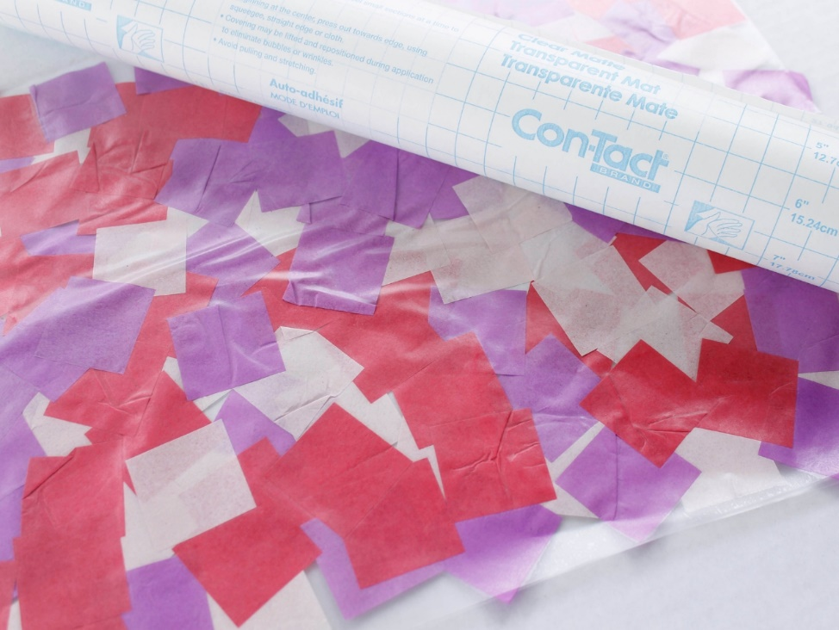

STEP 3
Once the contact paper is filled with the tissue paper, carefully place the other piece of contact paper over top. Smooth it out nicely so there aren't very many wrinkles. My best tip for this is to have two sets of hands. One person will line up with contact paper top with the bottom, while the other person holds the other end up. Slowly lay the contact paper down, smoothing as you go, until you reach the end.

STEP 4
Download the Free Suncatcher Hearts Printable here! It's best to print these on a white cardstock for easy tracing.

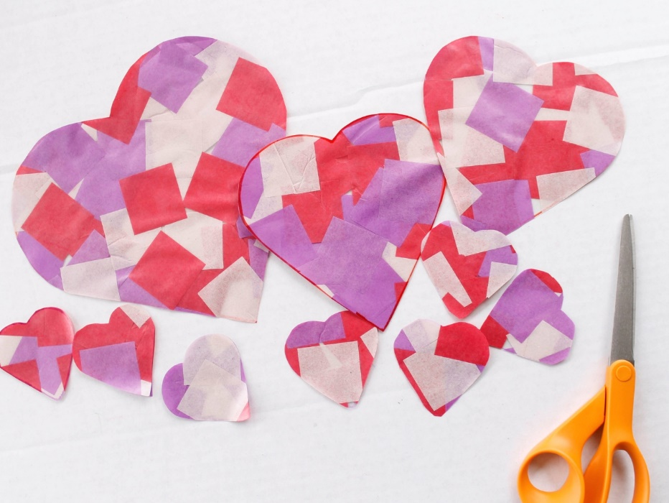
SWIPE TO PLAY

STEP 5
Using a Sharpie®, trace the Free Printable Valentine Heart Suncatcher templates onto the contact paper, and then cut out.
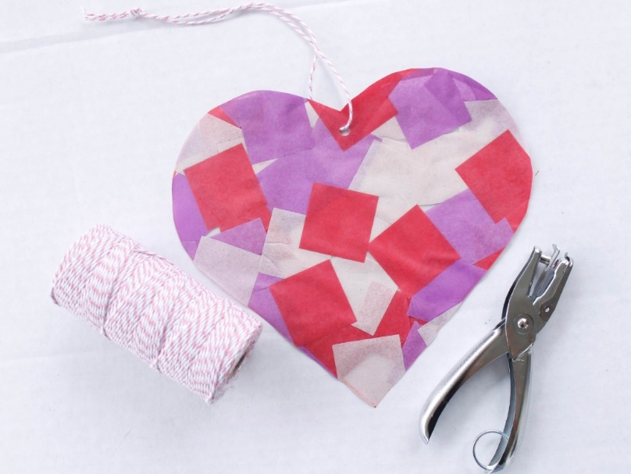

STEP 6
Next, punch a hole in each of the hearts. Thread some baker's twine through the hole and tie a knot. Repeat with the rest of the hearts.

STEP 7
Let your kids tape the Heart.

