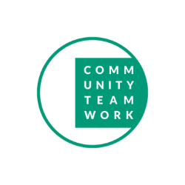

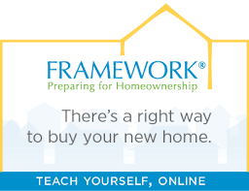
SPRING HAS SPRUNG IN THE REAL ESTATE MARKET
NOW IS THE TIME THE HIGHEST NUMBER OF HOUSES TO GO UNDER AGREEMENT

Finding it hard to fit in a First Time Home Buyer Course because of your schedule?
Framework online home buyer course can be done at your convenience!

Buying a home is a big deal, whether you’re doing it for the first time or getting back into the ever-changing market. When you educate yourself for smart homeownership with Framework, you’ll navigate every step of the process with confidence.

Realtors and Mortgage Bankers see these advantages of the Framework course:

- Client knows the facts and steps before you start your home search, clarify process confusion.
- Certified by CHAPA as a First Time Homebuyers course.
- Taken at client's convenience, 2 days or 6 months, 24/7, as long as taken on same computer.
- Client follow up conversation on phone or zoom can be scheduled Mon-Sat, 11am until 8pm.
- Course certification good for 2 years and can be extended with renewal.
- Client has access to course instructor before or after course is taken.
- Realtors will be happy to work with a certified serious client.

The Framework online homebuyer course is an alternative to CTI scheduled courses.
The course cost is an affordable: $75. After which, you are required to attend a one-on-one advisory session / exit briefing: $25. You will then receive your certificate of completion (required for many lender and other homebuyer incentives).

To find out more about and register for this course and all of CTI’s First-Time-Home-Buyer classes – Visit: www.commteam.org/first-time-home-buyer

Contact: Nancy J Wilson, CTI’s Property Owner Educator: 978.809.2773 | njwilson@commteam.org

