New center named for Rita O’Brien Dee
By PAIGE IMPINK News Correspondent paige@yourtowncrier.com
Oct 16, 2021

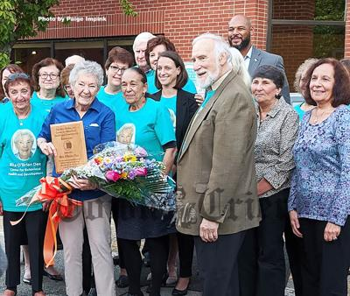
Tewksbury resident Rita O’Brien Dee, surrounded by friends, family, and colleagues, was honored by Community Teamwork in Lowell for her half century of service to the organization. The Rita O’Brien Dee Center for Behavioral Health & Development will be a resource for Community Teamwork and providers across the community who are working with children with behavioral, emotional, and developmental challenges. (Paige Impink photo)

TEWKSBURY — She thought she was attending a board meeting to accept a donation from a supporter of Community Teamwork, a vital services organization she works with in Lowell. But, when Rita O’Brien Dee saw her face on colorful t-shirts and friends and family under a festive tent, she realized something else was going on.
Community Teamwork CEO Karen Frederick welcomed O’Brien Dee and explained the surprise.
“We’d like to welcome Rita and acknowledge more than a half century of service to the community, and to the Community Teamwork family by dedicating The Rita O’Brien Dee Center for Behavioral Health & Development,” said Frederick.
Through a generous anonymous donation and a subsequent grant from the Greater Lowell Community Foundation, Community Teamwork was able to establish the program, located at the James Houlares Center on Phoenix Avenue in Lowell. The center will be the headquarters for programs and services that promote healthy social-emotional development for children, increase children’s success in school, strengthen children and families, and mitigate adversity through trauma-informed care.
According to Child and Family Services Division Director Meghan Siembor, “This opportunity could not have come at a better time… This opportunity enables us to meet a critical need and address a significant public health issue — children’s mental and behavioral health.”
Siembor praised O’Brien Dee.
“Her love for children is unparalleled as is her passion for giving back to the community,” said Siembor. “It truly is an honor for me and the staff across the Division of Child and Family services to be able to develop this Center in her honor.”
O’Brien Dee was visibly moved.
O’Brien Dee has been involved with Community Teamwork for 56 years. As a single parent raising five children on her own, she faced difficult struggles trying to work, put food on the table, and keep a roof over the heads of her family.
O’Brien Dee started her career as a teacher aide at Head Start, and earned her Associate’s Degree and quickly became an early childhood teacher at the center. O’Brien Dee was in the classroom for 27 years.
Upon retirement, O’Brien Dee joined the Head Start Policy Council and Community Teamwork’s Board of Directors. O’Brien Dee is also a member of many CTI committees and supports numerous initiatives.
According to data collected by CTI, mental health has emerged as a prominent community need, jumping from the fourth-most cited community need to the second-most cited need from the prior survey cycles. The impact of the pandemic is notable.
Key information also points to mental health as the most pressing issue in the community behind the need for better housing, according to CTI’s data for the greater Lowell community.
O’Brien Dee is known in Tewksbury for her participation in the Friends of the Library, the Tewksbury Historical Society, and is an active member of the Tewksbury Senior Center, Garden Club, the Democratic Town Committee, and is a former election worker.
O’Brien Dee has been an inspiration and example of giving back to the community, not just in Tewksbury, but in the greater Merrimack Valley.
If you would like to donate to help support the new Rita O’Brien Dee Center for Behavioral Health & Development, please contribute to the Greater Lowell Family Foundation c/o The Rita O’Brien Dee Center for Behavioral Health and Development

